Unit 17: Business Process Support

Assignment Brief

|  |  |
| --- | --- |
| Programme Title | HND in Computing |
| Student Name | Mohamed Raaiz |
| ANC ID | 1001358 |
| Unit Number and Title | Unit 17: Business Process Support |
| Academic Year | SP24 / 2024 |
| Unit Tutor | Mr. Anuradha Boyagoda |
| Assignment Title | Business Process Support Report on Selected organization |
| Issue Date |  |
| Submission Date | 09/06/2024 |
| Submitted on | 08/06/2024 |

Student Declaration

|  |
| --- |
| I certify that the assignment submission is entirely my own work and I fully understand the consequences of plagiarism. I understand that making a false declaration is a form of malpractice.  **Student signature: Date:** |

Final Grade

|  |  |  |
| --- | --- | --- |
| Grade: | Assessor Signature: | Date: |
| **Assessor Feedback:** | | |
| Grade: | Assessor Signature: | Date: |
| **Internal Verifier’s Comments:** | | |
| **Signature & Date:** | | |

Submission Guidelines

1. **Use the cover page provided in the previous page as your cover sheet** for the assignment you will be submitting and ensure that all the details are accurately filled. **All assignments should have the submitted with the above cover page which is properly filled.**
2. **Attach the assignment brief** as the first section of your assignment (Including the assignment criteria, summative feedback from and grading rubric).
3. Use an appropriate word processing software to develop your assignment.
4. Use A4 size pages for your assignments.
5. Use **font size 11** if you are using **Open Sans** or **Arial** font and font **size 12** if you are using **Times New Roman** font for the body of your assignment.
6. Use **font size 13 (bold)** if you are using **Open Sans** or **Arial** font and **font size 14 (bold)** if you are using **Times New Roman** font for **Main headings**. For **Sub-Headings** use **font size 12 (bold)** if you are using **Open Sans** or **Arial** font and font **size 12 (bold)** if you are using **Times New Roman**.
7. Use black text on a white background. **Avoid coloured backgrounds or text** in a colour other than black, unless you have special permission to use them.
8. Use **1.5 line spacing** and **2.53 cm (1”) wide margins** on all sides.
9. Justify your work (Ctrl+J).
10. **Insert a footer on each page** (except the title page) using **font size 10** if you are using **Times New Roman** and **font size 8** if you are using **Open Sans** or **Arial** font. Include the following details in the footer, Full Name, Student ID, Unit and the Page Number.
11. **Avoid** using **page borders** in your assignment body.

Important

1. All **submissions should accompany a Turnitin Report**. Any assignment which does not include a Turnitin Report will not be processed for grading. You are required to **attach the Turnitin report to the end of your assignment**. For this you can use file merging option.
2. Do note that **submission of the Turnitin report as an assignment will not be accepted** and will not be graded. In case a student has submitted a Turnitin Report only, without the assignment, that student will be awarded a **‘Fail’** grade.
3. It is **strictly prohibited to use texts in the form of images in your work** or **use text boxes** to present information other than to label a table or a figure.
4. Check the submission date of your assignment and submission instructions carefully. **Late submissions will not be accepted.**
5. Ensure that you give yourself enough time to complete the assignment by the due date and you are responsible for managing your own time effectively.
6. If you are unable to hand in your assignment on time and have valid reasons, you may apply (in writing) for extensions stating Extenuating Circumstance to AAO.
7. For all late submissions the final grade will be capped at a ‘**Pass’.**
8. **Failure to achieve the Pass criteria will result in a Referral grade.**
9. **Non-submission of work** without valid reasons will lead to an **automatic Failure** and you will be asked to complete an alternative assignment.
10. If you use ideas or work of other people in your assignment, reference them properly using Harvard Referencing system to avoid plagiarism. You have to provide both in-text citation and a reference list.
11. If you are proven to be guilty of plagiarism or any academic misconduct, your grade could be reduced to a Fail or at worst you could be administratively withdrawn from the course after a formal investigation.

Unit 17: Business Process Support

Assignment Brief

|  |  |
| --- | --- |
| Unit Number and Title | Unit 17: Business Process Support |
| Academic Year | SP24 -2024 |
| Unit Tutor | Mr. Anuradha Boyagoda |
| Assignment Title | Business Process Support Report on Selected organization |
| Issue Date |  |
| Submission Date |  |
| Submission Format | |
| **Task 1 – Business Process Support Proposal**  Discuss the use of data and information to support business processes and the value they have for a selected organisation / industry with effects of the use of data and information to support business processes in a real-world scenario.  **Task 2 – Action plan**  Use the organization relate sample / similar data set, from similar source to demonstrate and further analysyis relate to the use of data science techniques to make recommendations to support real-world business problems. Further this task Explore the tools and technologies associated with data science and how it supports business processes with a dashboard. | |
| Unit Learning Outcomes | |
| **LO1** Discuss the use of data and information to support business processes and the value they have for an identified organisation  **LO2** Discuss the implications of the use of data and information to support business processes in a real-world scenario.  **LO3** Explore the tools and technologies associated with data science and how it supports business processes.  **LO4** Demonstrate the use of data science techniques to make recommendations to support real-world business problems. | |
| Transferable skills and competencies developed | |
| Computing-related cognitive skills   * Demonstrate knowledge and understanding of essential facts, concepts, principles and theories relating to computing and computer applications. * Recognise and analyse criteria and specifications appropriate to specific problems, and plan strategies for their solutions. * Methods and tools: deploy appropriate theory, practices and tools for the design, implementation and evaluation of computer-based systems. * Recognise the professional, economic, social, environmental, moral and ethical issues involved in the sustainable exploitation of computer technology and be guided by the adoption of appropriate professional, ethical and legal practices.   Computing-related practical skills   * The ability to evaluate systems in terms of quality attributes and possible trade-offs presented within the given problem. * The ability to critically evaluate and analyse complex problems, including those with incomplete information, and devise appropriate solutions, within the constraints of a budget.   Generic skills for employability   * Intellectual skills: critical thinking; making a case; numeracy and literacy. * Contextual awareness, e.g. the ability to understand and meet the needs of individuals, business, and the community, and to understand how workplaces and organisations are governed. | |
| Vocational scenario | |
| You have been working as Business Support Analytics Intern in a Leading Business Process Support Consultancy Firm in Sri Lanka. As a part of your internship, Your Manager ask you to demonstrate the skills and knowledge on the importance and value of data and information in terms of optimising decision making and performance of a selected Organisation. For the purposes of the above, you are required to select a preferred organization / Industry.  You are required to provide a Business Process Support Proposal and Action plan with recommendations to be presented to the client at the end.  Organization relate sample / similar data sets can be download from **https://www.kaggle.com/** or similar source to demonstrate and further analysyis. | |
| Assignment activity and guidance | |
| **Task 1 – Business Process Support Proposal**   * 1. Brief introduction about the selected Organization / industry   2. Organisation Structure if available   3. Analyse the business processes and the supporting processes of the selected organization.   4. Discussion on how data and information support business processes, including the value they have for organisations.   5. Identify and differentiate semi structured and unstructured data.   6. Discussion of how data is generated through human- and machine generated data mechanisms and tools that could be used as part of process to manipulate and form meaningful data.   7. Discuss the social, legal, and ethical implications of using data and information to support business processes.   8. Describe common threats to data and how they can be mitigated on a personal and organisational level.   9. Evaluate the benefits and drawbacks of using application software to handle the business processes in selected organization.   10. Analyse the impact of using data and information to support business real- world business processes.   **Task 2 – Action plan**  *Use the organization relate sample / similar data set, download from https://www.kaggle.com/ or similar source to demonstrate and further analysyis.*   * 1. Discuss how tools and technologies associated with data science are used to support business processes and inform decisions.   2. Assess the impact and value of data and information, in relation to real-world business processes in practice used by organisations to support business processes and the tools for manipulation to form meaningful data.   3. Based on the organization relate sample data set that you use, prepare a Dashboard using appropriate tool in order to demonstrate and further analysyis.   + Your dashboard includes 6-8 widgets to present required information.   + Apply appropriate customizations that can be utilized to improve the managerial dashboard designed above.   1. Present your design of a data science solution to support decision making in relation to real-world problem faced by the selected organisation, assessing the benefits of using data to solve problems in practice.   + Justify recommendations that support decision making in reference to your real-world problem.   1. Critically evaluate your findings on Dashboard and suggested enhancement could optimize performance by delivering accurate and reliable information to increase his effectiveness.   + Summarise implementation of a data science solution, making clear how design performed a specific task to support problem solving or decision making.   + Conclude your case study with an evaluation on the use of data science techniques, addressing how these met selected organisation’s user and business requirements.   **You are encouraged to make Any Valid Assumptions with proper justifications.** | |
| **Recommended Resources**  *Please note that the resources listed are examples for you to use as a starting point in your research – the list is not definitive.* | |
| **Weblinks - general:**  https://builtin.com/ (2022) What Is Data Science? A Complete Guide [online] Available at: https://builtin.com/data-science [Accessed 1 August 2022]  https://datascience.codata.org/ (2022) Data science -Online data science journal [online] Available at: https://datascience.codata.org/ [Accessed 1 August 2022]  https://towardsdatascience.com/ (2022) Data Science Articles [Online] Available at: https://towardsdatascience.com/ [Accessed 1 August 2022]  https://www.simplilearn.com/ (2022) What is Data Science: Lifecycle, Applications, Prerequisites and Tools [online] Available at: https://www.simplilearn.com/tutorials/data-science-tutorial/what-is-data-science [Accessed 1 August 2022]  **Weblinks - open datastores & portals:**  https://data.gov.au/ (2022) Australian Government Datastore [online] Available at: https://data.gov.au/ [Accessed 1 August 2022]  https://data.gov.sg/ Singaporean Government Datastore [online] Available at: https://data.gov.sg/ [Accessed 1 August 2022]  https://data.london.gov.uk/ London Datastore [online] Available at: https://data.london.gov.uk/ [Accessed 1 August 2022]  https://daten.berlin.de/ Berlin Open Data [online] Available at: https://daten.berlin.de/ [Accessed 1 August 2022]  https://opendata.cityofnewyork.us/ Open Data for All New Yorkers [online] Available at: https://opendata.cityofnewyork.us/ [Accessed 1 August 2022]  **Journal articles:**  Fetais, A., Abdella, G.M., Al-Khalifa, K.N. and Hamouda, A.M. (2022) Business process re-engineering: a literature review-based analysis of implementation measures. Information. Volume 13, Issue 4. doi:10.3390/info13040185.  Reed-Berendt, R., Dove, E.S. and Pareek, M. (2021) The Ethical Implications of Big Data Research in Public Health: “Big Data Ethics by Design” in the UK‐REACH Study. Ethics &amp; Human Research, 44(1), pp.2-17. doi:10.1002/eahr.500111.  **Reading:**  Jeston, J. and Nelis, J. (2018) Business Process Management. 4th edn. Routledge.  Marr, B. (2015) Big Data: Using SMART Big Data, Analytics and Metrics to Make Better Decisions and Improve Performance. 1st edn. John Wiley & Sons, Ltd. | |

Learning Outcomes and Assessment Criteria

|  |  |  |
| --- | --- | --- |
| Pass | Merit | Distinction |
| **LO1** Discuss the use of data and information to support business processes and the value they have for an identified organisation | | **LO1 & LO2**  **D1** Evaluate the wider implications of using data and information to support business processes in an identified organisation. |
| **P1** Discuss how data and information support business processes and the value they have for organisations.  **P2** Discuss how data is generated and the tools used to manipulate it to form meaningful data to support business operations. | **M1** Assess the value of data and information to individuals and organisations in relation to real-world business processes. |
| **LO2** Discuss the implications of the use of data and information to support business processes in a real-world scenario. | |
| **P3** Discuss the social, legal, and ethical implications of using data and information to support business processes.  **P4** Describe common threats to data and how they can be mitigated on a personal and organisational level. | **M2** Analyse the impact of using data and information to support business real-world business processes. |
| **LO3** Explore the tools and technologies associated with data science and how it supports business processes | | **LO3 & LO4**  **D2** Evaluate the use of data science techniques against user and business requirements of an identified organisation. |
| **P5** Discuss how tools and technologies associated with data science are used to support business processes and inform decisions. | **P5** Discuss how tools and technologies associated with data science are used to support business processes and inform decisions. |
| **LO4** Demonstrate the use of data science techniques to make recommendations to support real-world business problems. | |
| **P6** Design a data science solution to support decision making related to a real-world problem.  **P7** Implement a data science solution to support decision making related to a real-world problem. | **M4** Make justified recommendations that support decision making related to a real-world problem. |

Higher Nationals - Summative Assignment Feedback Form

|  |  |  |  |  |
| --- | --- | --- | --- | --- |
| Student Name/ID |  | | | |
| Unit Title | Unit 17: Business Process Support | | | |
| Assignment No |  | Assessor | Mr. Anuradha Boyagoda | |
| Submission Date |  | Date Received 1st submission | |  |
| Re-submission Date |  | Date Received 2nd submission | |  |
| Assessor Feedback: | | | | |
| Grade: | Assessor Signature: | | | Date: |
| Resubmission Feedback: | | | | |
| Grade: | Assessor Signature: | | | Date: |
| Internal Verifier’s Comments: | | | | |
| Signature & Date: | | | | |

*\* Please note that grade decisions are provisional. They are only confirmed once internal and external moderation has taken place and grades decisions have been agreed at the assessment board.*

Higher Nationals – Grading Rubric

|  |  |  |
| --- | --- | --- |
| Grading Criteria | Achieved/Not Achieved | Comment |
| **P1** Discuss how data and information support business processes and the value they have for organisations. |  |  |
| **P2** Discuss how data is generated and the tools used to manipulate it to form meaningful data to support business operations. |  |  |
| **M1** Assess the value of data and information to individuals and organisations in relation to real-world business processes. |  |  |
| **P3** Discuss the social, legal, and ethical implications of using data and information to support business processes. |  |  |
| **P4** Describe common threats to data and how they can be mitigated on a personal and organisational level. |  |  |
| **M2** Analyse the impact of using data and information to support business real-world business processes. |  |  |
| **D1** Evaluate the wider implications of using data and information to support business processes in an identified organisation. |  |  |
| **P5** Discuss how tools and technologies associated with data science are used to support business processes and inform decisions. |  |  |
| **M3** Assess the benefits of using data science to solve problems in real-world scenarios. |  |  |
| **P6** Design a data science solution to support decision making related to a real-world problem. |  |  |
| **P7** Implement a data science solution to support decision making related to a real-world problem. |  |  |
| **M4** Make justified recommendations that support decision making related to a real-world problem. |  |  |
| **D2** Evaluate the use of data science techniques against user and business requirements of an identified organisation. |  |  |

# 

# Executive Summary

This thought affords a records science solution designed to tackle extensive challenges confronting our organization, a outstanding participant in the grocery store sector. With a major focus on refining decision-making processes and augmenting operational efficiency, the proposed initiative goals to harness data-driven insights to propel commercial enterprise growth and beautify aggressive standing.

**Key Points and Objectives:**

* Challenge: Our business enterprise struggles with disjointed Data sources, inefficient aid distribution, ineffective advertising tactics, and insufficient ordinary performance tracking.
* Proposed Solution: We advocate for enforcing a complete data science solution, which includes Data integration, preprocessing, exploratory facts analysis, predictive modeling, and dashboard creation.

**Objectives:**

* Consolidation of data evaluation skills to supply comprehensive insights into key metrics such as sales, inventory, and customer behavior.
* Improvement of dynamic proficiency through exact figures, pattern distinguishing proof, and appraisal of limited time viability.
* Helping functional effectivity through upgraded asset distribution, smoothed out activities, and continuous by and large execution observing.
* Encouraging an Data driven lifestyle inside the association, enabling partners to make informed determinations essentially founded on noteworthy experiences.

**Benefits:**

# Informed Independent direction: Tackling Data driven bits of knowledge engages partners to settle on essential decisions without hesitation, yielding most beneficial results. Functional Productivity: Further developed asset allotment and generally execution checking outcome in smoothed out tasks and worth reserve funds.

# Upgraded Client Experience: Client driven promoting techniques and item groupings got from measurements bits of knowledge raise client enjoyment and steadfastness. Execution Plan: The proposed answer will be finished in stages, starting with realities mix and preprocessing, noticed by means of exploratory records examination, prescient displaying, and dashboard advancement. Persistent difference and refinement will make specific its continuous significance and viability.

# End: Through the reception of Data science, our venture is situated to conquer state of the art challenges, encourage advancement, and secure supportable development in the serious supermarket industry. In synopsis, the proposed Data science answer vows to reform dynamic ideal models and open additional opportunities for our association's progression in the midst of the forceful grocery store scene

# Introduction

# Working inside the savagely serious supermarket industry, our business venture serves different client needs all through several areas. Focused on giving up and over score items and top notch administration, our general stores have acquired trust as go-to areas for customers searching for comfort and worth. In cutting edge dynamic venture scene, data has arise as a basic resource for organizations endeavoring to stay ahead. Perceiving the significance of Data driven navigation, our grocery store chain is setting out on a ride to tackle progressed examination and records science procedures to address key difficulties and trap prospects in the business. The point of this motivation is to characterize our methodology for forcing a measurements science answer customized to the particular prerequisites of our stores. By utilizing records actually, we objective to streamline dynamic cycles, improve functional proficiency, and hoist execution. This motivation highlights the meaning of embracing records science as an essential basic for riding development, development, and seriousness in the general store area.

# Problem Statement/Needs Assessment:

# In the savagely cutthroat scene of the basic food item save industry, our association wrestles with various moves that hinder our capacity to settle on educated choices and enhance functional productivity. One of the chief issues is the discontinuity of data sources across a lot divisions and store areas. This decentralized Data biological system prompts shortcomings in records assessment and dynamic cycles, as partners miss the mark on bound together perspective on key measurements, for example, pay execution, stock levels, and supporter conduct. Also, our general stores fight with wasteful helpful asset distribution, resulting in stockouts, abundance stock, and sub-par special procedures. Without right experiences into pay patterns, buyer inclinations, and stock interest, we can't dispense assets actually, fundamental to dismissed pay prospects and decreased benefit. Furthermore, the shortfall of ongoing execution checking makes it trying to find failing to meet expectations stores and regions for development, blocking our capacity to drive constant functional enhancement and development.

# Objectives:

**Specific Goals:**

* Consolidate Data evaluation abilities to provide comprehensive insights into quintessential metrics like sales, inventory, and customer behavior.
* Enhance decision-making via turning in precise forecasts, identifying trends, and assessing promotional effectiveness.
* Boost operational efficiency thru optimized resource allocation, streamlined operations, and real-time overall performance monitoring.
* Cultivate a data-driven way of life within the organization, empowering stakeholders to make knowledgeable selections based on actionable insights.

**SMART Objectives:**

* Specific: Each objective is truly defined and goals a particular project or want within the organization.
* Measurable: Success can be quantified using key overall performance symptoms (KPIs) such as income growth, inventory turnover, and purchaser delight scores.
* Achievable: The objectives are sensible and potential within the organization's assets and capabilities.
* Relevant: Achieving these targets is at once aligned with the organization's overarching desires of using growth and competitiveness in the grocery store industry.
* Time-bound: Clear timelines and milestones are mounted for each objective to ensure well timed growth and completion within unique timeframes.

**Solution/Approach:**

Our proposed arrangement involves carrying out an exhaustive Data science structure hand crafted to the specific longings of our grocery stores. This strategy includes various key parts:

1. **Data Combination**

We will assemble data from various sources, along with pay exchanges, client socioeconomics, stock levels, special exercises, and save generally speaking execution measurements. This data will be incorporated into a brought together insights distribution center or stage for examination.

1. **Data Preprocessing**

We will cleanse and preprocess the records to get to the bottom of problems such as lacking values, duplicates, and inconsistencies. Data transformation and feature engineering techniques will be employed to derive relevant insights from the raw data.

1. **Exploratory Data Analysis (EDA)**

We will behavior exploratory data evaluation to apprehend the underlying patterns, trends, and correlations within the data. Visualizations will be used to show off key metrics such as sales trends, customer behavior, inventory levels, and promotional effectiveness.

1. **Predictive Modeling**

We will improve predictive models to forecast sales, discover purchaser segments, optimize inventory levels, and consider merchandising effectiveness. Machine mastering algorithms such as regression, classification, and clustering will be utilized to build predictive fashions based on historical data.

1. **Dashboard Development**

We will diagram and develop a managerial dashboard the use of tools like Power BI or Tableau to existing actionable insights derived from the data. The dashboard will encompass interactive visualizations and KPIs associated to income performance, purchaser demographics, stock management, advertising effectiveness, and shop performance.

**Benefits/Expected Outcomes:**

**The implementation of our Data science solution is expected to yield several benefits and results for our organization**

1. **Informed Decision-Making**

Data-driven insights will empower stakeholders to make strategic selections with confidence, main to better results and accelerated competitiveness in the market.

1. **Operational Efficiency**

Efficient useful resource allocation and real-time performance monitoring will streamline operations, reduce costs, and decorate ordinary effectivity throughout our supermarkets.

1. **Enhanced Customer Experience**

Personalized marketing strategies and product offerings based totally on purchaser insights will enhance purchaser pleasure and loyalty, riding long-term boom and profitability.

1. **Data-Driven Culture**

By fostering a data-driven tradition within the organization, we will empower stakeholders at all ranges to leverage statistics efficiently in their decision making process, driving continuous improvement and innovation

**Implementation Plan:**

The implementation of our notion will be completed in phases, with every phase focusing on unique tasks and deliverables:

**Phase 1: Data Integration and Preprocessing**

Gather records from a number sources and integrate it into a centralized statistics warehouse.

Cleanse and preprocess the facts to ensure accuracy and reliability.

**Phase 2: Exploratory Data Analysis**

Conduct exploratory facts evaluation to become aware of trends, patterns, and correlations.

Visualize key metrics the use of charts, graphs, and other visualizations.

**Phase 3: Predictive Modeling**

Develop predictive models to forecast sales, optimize inventory levels, and evaluate advertising effectiveness.

Validate and refine the fashions primarily based on comments and overall performance metrics.

**Phase 4: Dashboard Development**

Design and enhance a managerial dashboard to current actionable insights and KPIs.

Test the dashboard for usability, functionality, and performance.

Phase 5: Deployment and Training

Deploy the data science solution throughout our supermarkets and furnish coaching to stakeholders on how to use the dashboard and interpret insights.

Throughout the implementation process, regular communication and collaboration will be maintained among group members, stakeholders, and exterior partners to make certain alignment with objectives, milestones, and timelines. Continuous evaluation and refinement will be conducted to optimize the solution and tackle any rising challenges or opportunities.

By following this implementation plan, we intention to efficaciously install our facts science answer and acquire our objectives of using growth, innovation, and competitiveness in the grocery store industry.

# 1.Brief Introduction: Supermarket Chain

Our selected organization is a renowned supermarket chain working globally, with a robust presence in some nations and regions. With a commitment to providing tremendous products, services, and shopping experiences, this supermarket chain has end up a family title synonymous with quality, convenience, and value.

Founded on the concepts of purchaser pride and operational excellence, the grocery store chain has installed itself as a market leader in the retail industry. Its large network of shops caters to a diverse customer base, supplying a broad vary of products which includes groceries, fresh produce, household essentials, electronics, apparel, and more.

Driven via innovation and a customer-centric approach, the grocery store chain consistently adapts to evolving consumer preferences and market trends. Through strategic partnerships, environment friendly supply chain management, and funding in technology, the organization continues a competitive side in an increasing number of dynamic and competitive market landscape.

Committed to sustainability and company social responsibility, the grocery store chain actively engages in initiatives aimed at lowering environmental impact, promotion ethical sourcing practices, and helping nearby communities. By aligning enterprise targets with social and environmental values, the enterprise demonstrates a steadfast dedication to growing shared fee for stakeholders.

In summary, the selected supermarket chain exemplifies excellence in retail operations, leveraging its large resources, expertise, and patron insights to deliver unparalleled cost to shoppers worldwide.

# 2. Organization Structure: Supermarket Chain

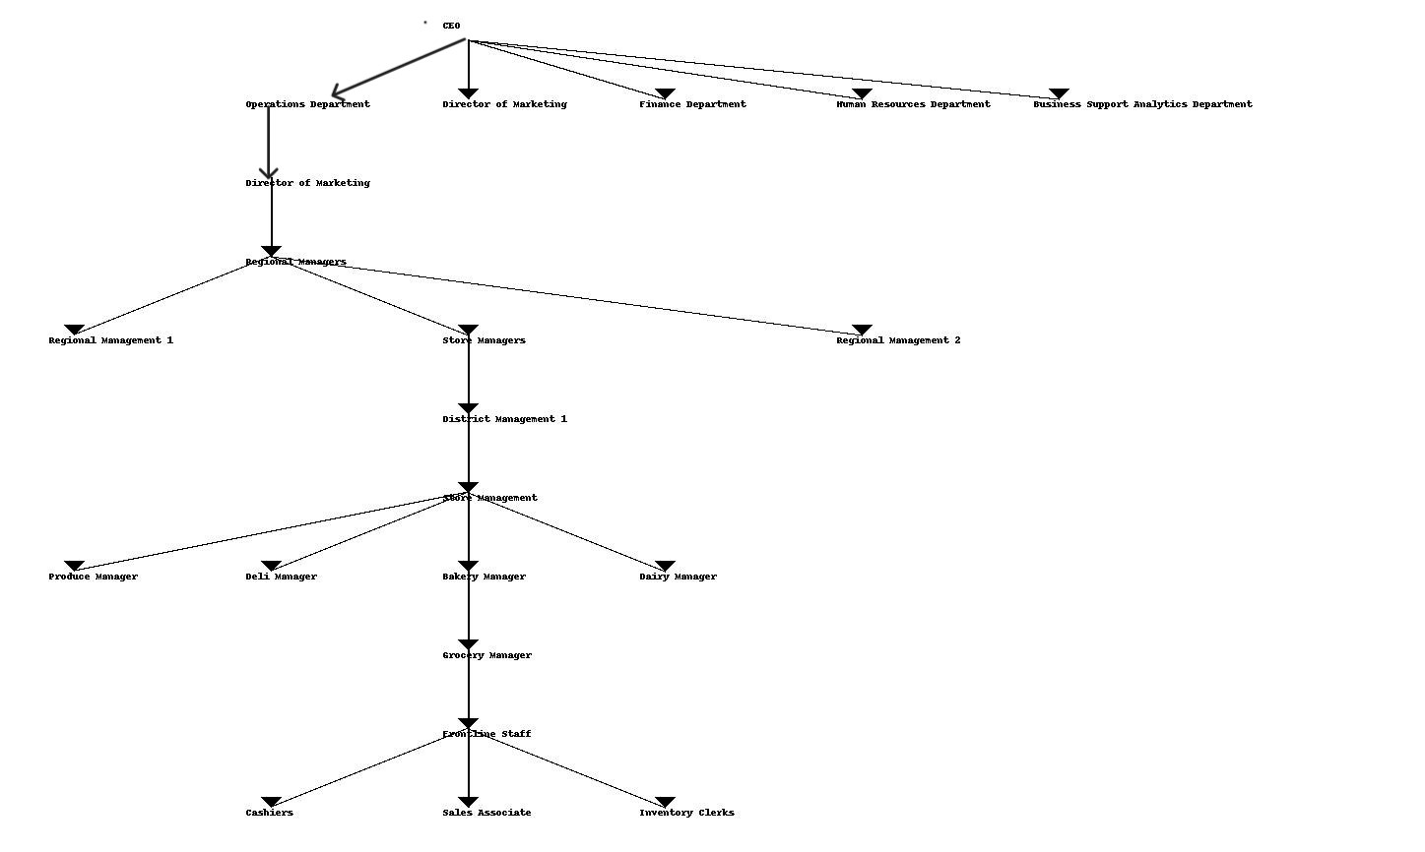

The organizational shape of a supermarket chain generally consists of quite a few hierarchical degrees designed to efficiently control operations, make certain consumer satisfaction, and force profitability. While precise organizational buildings may additionally fluctuate based totally on elements such as corporation size, geographical scope, and company strategy, the following represents a frequent framework for a grocery store chain

**Corporate Headquarters**

At the pinnacle of the hierarchy is the company headquarters, accountable for setting average strategic direction, monetary management, and overseeing key features such as marketing, finance, human resources, and operations.

**Regional Management**

Below the corporate level, regional management groups oversee operations inside precise geographic areas or territories. These regional managers are accountable for imposing corporate strategies, coordinating things to do throughout multiple stores, and making sure compliance with organization policies and standards.

**District Management**

Within every region, district managers are accountable for overseeing a cluster of shops within a defined area. They work intently with keep managers to optimize performance, address operational challenges, and ensure consistent execution of organization initiatives.

**Store Management**

At the operational level, save managers are accountable for the daily administration of individual grocery store locations. They oversee store personnel, control inventory, make certain compliance with health and security regulations, and supply awesome patron service.

**Department Managers**

Within every store, branch managers oversee unique departments such as produce, deli, bakery, meat, dairy, and grocery. They are responsible for stock management, merchandising, workforce supervision, and purchaser engagement inside their respective departments.

**Frontline Staff**

Frontline staff, including cashiers, income associates, inventory clerks, and patron service representatives, play a fundamental role in delivering a superb purchasing journey for customers. They grant assistance, manner transactions, maintain keep cleanliness, and uphold provider standards.

**Proposed Organizational Structure:**

In instances the place a grocery store chain might also not have a definitely defined organizational structure, it is imperative to advise a suitable framework aligned with enterprise best practices and organizational objectives. The proposed shape need to facilitate high quality communication, decision-making, and accountability while aiding the organization's strategic goals.

A advocated strategy may want to involve a matrix organizational structure, combining practical and divisional factors to promote collaboration, agility, and specialization. This shape would feature cross-functional teams responsible for key initiatives such as product innovation, patron experience enhancement, and market expansion, supported by centralized functions for governance, useful resource allocation, and performance management.

By implementing a well-defined organizational shape tailored to the unique wants of the grocery store chain, the organization can streamline operations, optimize resource utilization, and force sustainable growth in a competitive market environment.

# 3. Analysis of the Business Processes and Supporting Processes in the Supermarket Chain

The tasks of a store chain include a large number of interconnected business endeavor strategies focused on effectively dealing with various parts of retail activities, from obtainment and stock organization to buyer transporter and promoting. How about we examine the key endeavor techniques and their helping systems inside the setting of the chose store chain

**1. Procurement Process:**

**Business Interaction**

* The acquisition method incorporates obtaining items from providers to finish off stock and satisfy supporter need. It comprises of activities like seller choice, discussion, buying, and supplier relationship the board.

**Supporting Procedures**

* Dealer comparison and performance tracking, inventory forecasting, order management, and logistics coordination to ensure that goods are shipped to stores on time are examples of supporting procedures for procuremen0t.

**2. Inventory Management Process:**

**Business Process**

* Inventory management is fundamental for optimizing stock levels, minimizing out-of-stock situations, and maximizing inventory turnover. It encompasses things to do such as inventory tracking, stock replenishment, shelf management, and stock valuation.

**Supporting Processes**

* Supporting procedures for inventory administration may additionally consist of demand forecasting, stock optimization algorithms, barcode scanning systems, RFID science for real-time tracking, and automated replenishment structures to hold most excellent inventory levels.

**3. Sales and Customer Service Process:**

**1.Sales**

* Alright, so the sales process involves interacting with customers, facilitating transactions, and making sure people have a good shopping experience. It takes them from the very beginning when a customer first shows up all the way through completing the purchase.

**There are a few key things that support this process:**

* First, stores use point-of-sale systems, or POS, at the checkout lines. These allow them to quickly process sales, manage inventory levels in real-time, take payments, and see what customers are buying the most. It helps everything run smoothly and efficiently.
* Also, some places have self-checkout kiosks now. Customers can scan and pay for their own items without waiting in a line. This speeds things up and makes shopping more convenient. People seem to like having that option available.
* Another important thing is loyalty programs. Stores give customers rewards like points or discounts for coming back. It encourages repeat business and helps stores get to know customers better over time.
* The stores also use customer relationship management, or CRM software. This allows them to track what people buy, get their feedback, and then target ads or offers toward individuals. It helps strengthen those customer relationships.
* Finally, employee training is key. Making sure staff really know the products and can help customers is important for customer service. Training programs help give employees the tools and confidence to do a great job serving people.

**2.Customer**

* Alright, so basically there are a few key parts to how a supermarket handles customer service
* First, they have a customer service help desk or call center that deals with any questions, issues or complaints from customers however they contact - whether by phone, email or live chat. The goal is to quickly resolve problems and make sure customers are happy.
* Next, there are standard procedures for dealing with complaints. This makes sure each one is properly documented, escalated if needed, and addressed in a timely manner. The goal is keeping customers satisfied.
* Also, employees go through ongoing training to improve their communication, problem solving and handling difficult situations. This helps them provide great service no matter the customer or situation.
* The supermarket also collects feedback from customers through surveys, online forms or social media. They analyze this to see any trends, what can be improved, and how to make the shopping experience even better.
* Finally, they regularly review everything and look for ways to make the processes more efficient. This could mean fixing bottlenecks, adopting best practices or using new technology. The goal is always enhancing customer service and satisfaction.
* By managing customer service well, supermarkets can create a really positive shopping experience for customers. This leads to customers coming back, telling others, and overall business growth.

**4. Marketing and Promotions Process**

**Business Process**

* The advertising and promotions manner aims to entice customers, power sales, and build manufacturer loyalty thru centered advertising campaigns, promotional offers, and advertising initiatives.

**Supporting Processes**

* Supporting procedures for advertising and promotions may additionally encompass market lookup and analysis, patron segmentation, campaign management tools, digital advertising and marketing platforms, loyalty program analytics, and social media monitoring equipment to track campaign effectiveness and customer engagement.

**5. Supply Chain Management Process**

**Business Process**

* Supply chain management entails coordinating the waft of items and offerings from suppliers to customers, optimizing logistics, and managing stock throughout the whole provide chain.

**Supporting Processes**

* Supporting methods for furnish chain management may also encompass provider collaboration platforms, transportation management systems, warehouse administration systems, route optimization software, and furnish chain visibility equipment to music shipments and display delivery performance.

**6. Financial Management Process:**

**Business Process**

* Financial administration encompasses budgeting, monetary planning, fee tracking, and financial reporting to make sure financial stability and profitability.

**Supporting Processes**

* Supporting processes for economic management may also include accounting software, budgeting tools, economic evaluation models, cash glide forecasting, and internal controls to monitor economic performance and compliance with regulatory requirements.
* By examining these business methods and their assisting processes, the selected grocery store chain can pick out opportunities for improvement, streamline operations, and beautify normal efficiency and effectiveness in turning in value to customers whilst accomplishing enterprise objectives.

Summary

|  |  |  |
| --- | --- | --- |
| Main Task | Business Process | Supporting Processes |
| Procurement Process | * Dealer selection * Purchasing * Handling the relationship with the supplier | * Dealer comparison and performance tracking * Inventory forecasting, order management * Logistics coordination |
| Inventory Management Process | * Optimizing stock levels * maximizing inventory turnover * Handling the stock out products as inventory tracking * Stock replenishment * Shelf management * Stock valuation | * Demand forecasting * Stock optimization algorithms * Barcode scanning systems * RFID science for real time tracking * Automated replenishment structures |
| Sales | * Engaging with customers * Money Transactions * Guaranteed for a positive shopping experience | * Point-of -sales(POS)systems. * Self Checkouts * Loyalty programs * Software(Customer Relationship Management(CRM)) * Training the employee Programs |
| Customer Service | * Handling inquiries issues and complaints * Resolving customer problems promptly | * Call center or customer service helpdesk * Resolve complaint procedures * Training and development ongoing for the staff * Feedback and analysis * Continuous improvements |
| Marketing Promotion& Process | * Attracting the customer via promotions and advertising. * Handling sales & brand loyalty | * Research market& analysis * Customer segmentation * Campaign management tools * Digital marketing platforms * Analysis of loyalty programs * Monitoring via social media. |
| Supply Chain Management Process | * Planning the progression of merchandise from providers to clients. * Improve logistics * Overseeing stock across the store network. | * Supplier cooperation stages. * Manage the transportation systems * Store management systems * Route for the optimization software * Visibility tool for the supply chain |
| Financial Management Process | * Budgeting & financial planning * Tracking the expense * Financial reporting | * Software for accounting * Tools for budgeting * Financial analysis models * Cash flow forecasting * Internal controls |

# 4. Discussion on the Role of Data and Data in Supporting Business Processes

Data and statistics play a pivotal function in assisting and optimizing more than a few business techniques inside a grocery store chain. This is a discourse on the way measurements and insights make a commitment to the viability and cost of these cycles

**1. Data-Driven Decision Making**

* Data and insights provide valuable insights into customer behavior, preferences and purchasing habits.
* By reviewing sales data, customer feedback and market trends, grocery chains can make informed choices about product assortment, pricing strategies, advertising campaigns and inventory management. This data-driven strategy enables businesses to assume customer demand, optimize product offerings, and maximize income potential.

**2. Operational Efficiency**

* Data and facts assist streamline operational tactics and enhance effectivity throughout the furnish chain.
* By leveraging Data analytics and technological know-how solutions, supermarkets can optimize inventory levels, decrease stockouts, limit waste, and enhance logistics and distribution processes.
* Real-time facts visibility enables proactive decision-making, enabling agencies to reply rapidly to altering market prerequisites and operational challenges.

**3. Customer Experience Enhancement**

* Data and facts enable supermarkets to customize the patron trip and supply tailored offerings to meet character wishes and preferences.
* Customer statistics amassed via loyalty programs, online platforms, and POS systems enable agencies to section their purchaser base, target unique demographics with applicable offers, and grant customized recommendations.
* By understanding client preferences and purchasing habits, supermarkets can create engaging purchasing experiences that foster consumer loyalty and satisfaction.

**4. Marketing Effectiveness**

* Data and Data guide centered marketing initiatives via offering insights into customer demographics, buy history, and engagement metrics.
* By examining advertising campaign performance data, supermarkets can determine the effectiveness of one-of-a-kind promotional strategies, optimize marketing spend, and allocate assets to initiatives that supply the very best return on investment.
* Data-driven advertising approves organizations to reach the proper audience with the right message at the right time, maximizing the have an impact on of advertising efforts and riding income growth.

**5. Risk Management and Compliance**

* Data and statistics help hazard administration and compliance efforts through enabling agencies to identify and mitigate manageable risks, such as fraud, theft, and regulatory non-compliance.
* By analyzing transactional Data and monitoring inner controls, supermarkets can detect anomalies, unauthorized activities, and compliance violations in real time, enabling instantaneous corrective action and making sure adherence to regulatory requirements. Data-driven threat administration techniques assist guard assets, guard company reputation, and preserve stakeholder trust.
* In summary, Data and data are imperative property that power cost advent and aggressive advantage for grocery store chains.
* By leveraging data analytics, science solutions, and advanced selection guide tools, businesses can optimize business processes, enhance operational efficiency, customize patron experiences, and mitigate risks, eventually accomplishing sustainable boom and profitability in a dynamic and evolving retail landscape.

**Assess the value of data and information to individuals and organizations in relation to real-world business processes.**

1. **Data-Driven Decision Making**

* Data-driven decision-making underscores the value of using Data and statistics to Data both strategic and day-to-day decisions inside a company.

**Application**

* In the context of a supermarket, statistics gleaned from income transactions, consumer interactions, and market trends performs a pivotal function in shaping selections related to product selection, pricing strategies, and promotional campaigns.
* Through the learned usage of data bits of knowledge, stores can upgrade stock administration, modify publicizing attempts, and at last increment standard business undertaking execution.

1. **Customer Relationship Management (CRM)**

* Customer Relationship Management (CRM) focuses on nurturing and preserving strong consumer connections by using data and analytics to provide personalized interactions and fulfill client desires efficiently.

**Application**

* In the context of supermarkets, implementing CRM ideas includes shooting and evaluating purchaser data, identifying buying trends, and growing customized engagements thru loyalty programs, targeted promotions, and individualized recommendations.
* By appreciation patron preferences and behaviors, supermarkets can decorate loyalty, drive ordinary purchases, and increase common consumer pride levels.

1. **Competitive Intelligence:**

* Competitive Genius involves systematically gathering, analyzing, and decoding data and records associated to competitors and market dynamics to gain a competitive advantage.

**Application**

* Supermarkets make use of competitive intelligence to reveal competitors' pricing strategies, product assortments, and promotional activities. This allows them to remain knowledgeable about market trends, assume competitor actions, and alter their very own techniques accordingly. By harnessing market statistics and customer insights, supermarkets can pick out rising trends, forecast competitor actions, and adapt their own strategies proactively to keep a competitive foothold within the market.

1. **Value Chain Analysis:**

* Value chain evaluation scrutinizes the a number things to do and strategies within an company to pinpoint avenues for cost advent and aggressive differentiation.

**Application**

* In the context of a supermarket, price chain analysis involves evaluating every aspect of the provide chain, spanning procurement, distribution, sales, and purchaser service. By delving into data and data pertinent to every stage, supermarkets can pinpoint inefficiencies, streamline operations, and beautify typical price delivery to customers.

1. **Technology Adoption Frameworks:**

* Technology adoption frameworks, such as the Technology Acceptance Model (TAM) or the Unified Theory of Acceptance and Use of Technology (UTAUT), delve into the elements influencing individuals' include and utilization of technology.

**Application**

* Supermarkets follow these frameworks to gauge both employees' and customers' reception and utilization of technology-driven solutions, along with self-checkout kiosks, mobile applications, and on line ordering platforms.
* By gaining insights into users' attitudes and behaviors towards technology, supermarkets can tailor their techniques to optimize adoption costs and maximize the leverage of records and Data.

**The Transformative Value of Data and Information in Enhancing Real-World Business Processes**

* In the contemporary business landscape, records and information have emerged as invaluable property that power decision-making, enhance operational efficiency, and grant a competitive edge.
* For humans and organizations alike, the strategic utilization of data is paramount in navigating the complexities of real-world business processes.
* This assessment explores the imperative fee of records and information, emphasizing its transformative influence on decision-making, patron relationship management, aggressive intelligence, value chain analysis, and science adoption.
* Additionally, it delineates an action graph for leveraging these insights to optimize supermarket operations, ensuring sustained increase and success in a dynamic market environment.

**Real-World Business Processes and the Value of Data**

* Data-driven decision-making is central to modern enterprise practices, enabling corporations to base strategic and everyday choices on empirical proof alternatively than intuition.
* In the context of a supermarket, leveraging statistics from sales transactions, patron interactions, and market traits can considerably beautify product selection, pricing strategies, and promotional campaigns.
* Effective data utilization leads to extended stock management, focused marketing efforts, and usual commercial enterprise performance.

**Customer Relationship Management (CRM)** is some other essential region the place information plays apivotal role. By capturing and inspecting customer data, supermarkets can discover buying patterns, tailor loyalty programs, and create personalized marketing campaigns. This deep grasp of patron preferences fosters loyalty, drives repeat purchases, and enhances purchaser satisfaction.

Competitive Genius involves the systematic gathering and evaluation of facts associated to rivals and market dynamics. Supermarkets can use this records to screen competitors' pricing strategies, product assortments, and promotional activities. Staying informed about market trends and competitor movements lets in supermarkets to proactively adapt their strategies, keeping a aggressive advantage.

Value chain evaluation scrutinizes the various things to do inside an organization to identify possibilities for price introduction and aggressive differentiation. For supermarkets, this entails evaluating every element of the furnish chain, from procurement and distribution to income and consumer service. By analyzing data at every stage, supermarkets can pinpoint inefficiencies, streamline operations, and beautify cost delivery to customers.

Technology adoption frameworks, such as the Technology Acceptance Model (TAM) and the Unified Theory of Acceptance and Use of Technology (UTAUT), help companies apprehend the factors influencing the acceptance and use of technology. In supermarkets, these frameworks can check how employees and clients perceive technology-driven solutions like self-checkout kiosks, cell applications, and online ordering platforms. Insights from these assessments allow supermarkets to optimize technological know-how adoption strategies, maximizing the benefits of data and information.

**Tools for Data Manipulation and Insight Generation**

* Effective facts utilization requires robust tools and technologies. Data analytics systems like Tableau, Power BI, and Google Analytics facilitate records visualization, exploratory analysis, and real-time reporting. Statistical evaluation software program such as R, Python, and SPSS allows advanced statistical analyses and information manipulation. Data mining strategies like clustering, classification, and affiliation rule mining discover treasured patterns and relationships inside data. Machine getting to know and AI algorithms further beautify predictive modeling and selection automation, unlocking deeper insights from complicated datasets.

**Action Plan for Implementing Data-Driven Strategies**

**To illustrate the practical software of these concepts, consider a grocery store chain implementing a data-driven approach:**

* Identify Key Metrics and Data Sources: Focus on metrics such as income data, consumer demographics, inventory levels, and advertising effectiveness.
* Select an Appropriate Tool: Utilize Microsoft Power BI for its complete data connectivity, modeling, visualization, and dashboard introduction capabilities.
* Data Integration and Modeling: Connect to a variety of statistics sources, clean, transform, and model the data for consistency and accuracy.
* Dashboard Design: Develop a managerial dashboard in Power BI, incorporating key metrics and visualizations applicable to decision-making.
* Implement Data-Driven Decision-Making: Roll out the dashboard throughout the organization, providing education and support to stakeholders.
* Monitor and Evaluate Performance: Continuously display the dashboard’s overall performance and gather consumer comments for improvements.
* Drive Continuous Improvement: Use insights from the dashboard to optimize resource allocation, decorate advertising strategies, and improve shop performance.

By following this action plan, the grocery store chain can harness the full plausible of statistics and information, using operational efficiency, knowledgeable decision-making, and sustained aggressive advantage. This comprehensive approach underscores the transformative price of data in real-world commercial enterprise processes, paving the way for innovation and boom in an increasingly more data-driven world.

**Tools used to manipulate it to form meaningful data to support business operations.**

1. **Data Analytics Tools:**

* CRM systems accumulate and analyze buyer records to decorate relationships and beautify sales.

**Application**

* Supermarkets rent CRM constructions to control patron Data, customize marketing, and tailor promotions. By analyzing purchase documents and preferences, they can ship headquartered presents to customers, growing profits and loyalty

1. Customer Relationship Management (CRM) Systems:

* CRM systems accumulate and analyze buyer records to decorate relationships and beautify sales.

**Application**

* Supermarkets rent CRM constructions to control patron Data, customize marketing, and tailor promotions. By analyzing purchase documents and preferences, they can ship headquartered presents to customers, growing profits and loyalty

1. **Inventory Management Software:**

* Inventory administration software program application automates monitoring and replenishment to optimize inventory levels.

**Application**

* By the utilization of such software, supermarkets can divulge stock in real-time, predict demand, and reduce extra stock. This improves cash float and reduces storage expenses while preventing stockouts.

1. **Market Research Tools:**

**Clarification**

* Market query apparatuses gather records on market patterns, buyer inclinations, and contender exercises.

**Application**

* Supermarkets use surveys, focal point groups, and competitor analysis reviews to apprehend market dynamics. This helps them become aware of growth opportunities, refine offerings, and stand out from competitors.
* By using these tools and methods, supermarkets can efficaciously analyze Data to enhance operations and obtain a aggressive facet in the market.

# 5.Identifying and Differentiating Semi-Structured and Unstructured Data in a Supermarket

In the context of a supermarket, data can be classified into unique categories based on its shape and stage of organization. We should choose and separate semi-structures and unstructured realities inside this environment:

1. **Semi-Structured Data**

**Sales Transaction Records**

Semi-Structured= Deals exchange documents normally have a characterized shape with equipped fields, for example, date, time, things bought, amount, and cost. these records comply with a consistent format, they might also incorporate additional data such as customer loyalty numbers or payment methods, which can fluctuate from transaction to transaction.

**Inventory Databases:**

Semi-Structured= Inventory databases comprise structured Data about product SKUs, descriptions, portions on hand, reorder levels, suppliers, and places within the store While the basic Data elements are structured, additional attributes or custom fields can be added over time to meet specific business needs or product categories.

**Customer Feedback Forms:**

Semi-Structured=Most customer feedback forms have predefined fields where structured records like ratings, comments, and suggestions can be entered. However, customers may additionally grant free-text responses, which introduce a semi-structured component to the data. While the structure itself has a structured format, the content material of the responses can also range in size and format.

1. **Unstructured Data:**

**Social Media Comments:**

Unstructured=Social media feedback from systems like Twitter, Facebook, and Instagram include unstructured text facts in the shape of user-generated posts, comments, reviews, and messages. This data lacks a predefined schema and may additionally consist of a vast range of topics, sentiments, and language variations.

**Product Reviews**:

Unstructured= Product critiques amassed from quite a number on line platforms or patron feedback channels consist of unstructured textual content facts containing opinions, experiences, and pointers shared by means of customers. These reviews can also vary in length, tone, and content, making them challenging to categorize or analyze using ordinary structured statistics methods.

**Email Communications:**

Unstructured=Email communications, including consumer inquiries, complaints, and correspondence with suppliers, symbolize unstructured textual records that frequently lacks a standardized format. Emails may additionally comprise free-form text, attachments, and metadata, making them difficult to analyze without advanced natural language processing (NLP) techniques.

1. **Differentiation:**

# Semi-structured Data commonly follows a predefined configuration or construction, with fitted fields and stable truth types. Despite the fact that there can be variety even in certain fields, the normal Data design is shockingly normalized and can be taken care of by standard data set administration frameworks. Then again, unstructured Data doesn't have a foreordained design or structure, which makes it challenging to coordinate, break down and decipher.

# Unstructured exchanges frequently contain literary substance, pictures, sound and video documents that require progressed Data handling procedures, for example, message mining, opinion examination and photograph acknowledgment to separate important data.

# In conclusion, whereas semi-structured grocery store statistics layouts typically have more descriptive fields, unstructured records have very different content and may necessitate specialized evaluation and interpretation tools and techniques.

# 6.Discussion of Data Generation Mechanisms and Tools for Supermarkets

In supermarkets, mechanisms driven by humans and machines produce data that offers useful insights into consumer behavior, operational effectiveness, and market trends. We should investigate how records are made through these instruments and the devices that can be utilized to control and draw significant experiences from this Data

1. **Human-Generated Data Mechanisms:**

**Sales Transactions:**

* Human interaction: a sales transaction is initiated by a customer who interacts with a cash register or register to buy a product.
* Data generation: Each transaction generates data such as product SKU, quantity, price, billing method and timestamp.
* Tool : Point-of-sale (POS) systems, barcode readers, and cash registers record transaction records in real time, can be integrated with customer and inventory databases for 'analytical' purposes.

**Customer Feedback:**

* Human interactions: customers provided feedback through several channels such as in-store feedback cards, online surveys, or verbal communication with employees.
* Data Generation: Response types or survey responses generate data containing ratings, comments, recommendations, and sentiments.
* Tools: Customer relationship administration (CRM) software, survey platforms, and sentiment evaluation equipment manner and analyze comments records to discover trends, issues, and possibilities for improvement.

1. **Machine-Generated Data Mechanisms:**

**RFID Technology:**

* Machine Interaction: Radio-frequency identification (RFID) tags embedded in product packaging or attached to buying carts interact with RFID readers installed throughout the store.
* Data Generation: RFID readers seize Data about product movements, stock levels, and purchaser traffic in real-time.
* Tools: RFID structures combine with inventory management software program to song stock levels, monitor merchandise flow, and automate replenishment procedures based on demand patterns.

**Internet of Things (IoT) Sensors:**

* Machine Interaction: IoT sensors deployed in refrigeration units, storage areas, and checkout counters gather environmental records such as temperature, humidity, and foot traffic.
* Data Generation: Sensor readings generate data streams that provide insights into equipment performance, electricity consumption, and keep conditions.
* Tools: IoT platforms and analytics tools procedure sensor data to optimize power usage, forestall equipment failures, and ensure compliance with meals safety regulations.

1. Tools for Manipulating and Forming Meaningful Data:

**Data Integration Platforms:**

* Tools: Enterprise Data integration systems such as Apache Kafka, Informatica, or Talend enable the aggregation of statistics from disparate sources, together with POS systems, CRM databases, IoT devices, and exterior data feeds.

**Data Warehousing and Data Lakes:**

* Tools: Data warehousing solutions like Amazon Redshift, Google BigQuery, or Snowflake grant centralized repositories for storing and organizing structured and unstructured data. Data lakes such as Apache Hadoop or Amazon S3 permit for the storage of raw, unprocessed facts for future analysis.

**Data Analytics and Business Intelligence (BI) Tools:**

* Tools: Analytics systems like Tableau, Microsoft Power BI, or Google Data Studio allow data visualization, ad-hoc querying, and interactive dashboards for exploring and examining supermarket records to uncover insights and trends.

**Machine Learning and Predictive Analytics:**

* Tools: Machine getting to know frameworks such as TensorFlow, scikit-learn, or PyTorch facilitate predictive modeling, consumer segmentation, demand forecasting, and advice engines based totally on historic statistics patterns.

**Natural Language Processing (NLP) and Sentiment Analysis:**

* Tools: NLP libraries such as NLTK, spaCy, or Hugging Face's Transformers allow text processing, sentiment analysis, and subject matter modeling of consumer feedback, social media comments, and product critiques to extract actionable insights.

By leveraging these data technology mechanisms and tools, supermarkets can harness the electricity of both human-generated and machine-generated records to inform strategic decision-making, optimize operational processes, beautify customer experiences, and pressure enterprise boom in a competitive retail landscape.

# 7. Discussion of Social, Legal, and Ethical Implications of Data Usage in Supermarkets

In leveraging data and statistics to help enterprise processes, supermarkets should think about and address various social, legal, and moral implications to make sure accountable and sustainable practices. We should investigate these ramifications:

**Social Implications:**

**Privacy Concerns:**

**Social concerns**

Clients may likewise have worries about the assortment, stockpiling and utilization of their own data like buy history, inclinations and contact data.

**Alleviation**

Stores should lay out straightforward security strategies, acquire explicit agree to gather records and carry serious areas of strength for out safety efforts to shield client Data from unapproved access or abuse.

**Digital Divide:**

**Social Concern**

Not all clients could moreover have comparable get right of entry to mechanical aptitude or modernized stages, probably deteriorating abberations in permission to things, benefits, and re-tried experiences.

**Alleviation**

Supermarkets need to guarantee that cutting-edge drives supplement conventional channels, giving various touchpoints to client responsibility and obliging various tendencies and inventive limits.

**Legal Implications:**

**Data Protection Regulations:**

**Lawful necessity**

stores should agree with Data security rules and guidelines in regards to the assortment, handling and stockpiling of individual Data, like the Overall Data Assurance Guideline (GDPR) in the European Association or the California Shopper Assurance Act (CCPA) in the US.

**Consistence**

Shops ought to fan out a veritable affiliation structure, entire safety by way of layout standards and lead common reviews to warranty consistence with crook stipulations and remain away from anticipated fines or teaches for rebellion.

**Intellectual Property Rights:**

To prevent copyright encroachment or legitimate debates, supermarkets must consider licensed innovation freedoms when utilizing outsider data like product images, logos, or protected text.

Stores get essential authorizations or licenses with utilize protected material, comply to honest use rules, and regard the psychological property privileges of content material makers and prized freedoms holders with a reasonable level of investment.

**Ethical Implications:**

**Algorithmic Bias:**

The moral issue is that data-based dynamic algorithms might unintentionally perpetuate biases or discrimination based on gender, race, or socioeconomic status, which could lead to unfair treatment or outcomes.

To avoid tendency, guarantee fair-minded treatment, and stay aware of moral guidelines, stores every now and again need to review computations, confirm data inputs, and integrate sensibility and straightforwardness principles into estimation improvement.

**Consumer Manipulation:**

# Moral contemplations expect grocery stores to forgo utilizing insights and records to impact client conduct through designated publicizing, estimating methodologies, or convincing messages, as this can think twice about and dynamic freedom.

# Stores ought to stick to moral advertising rehearses, be straightforward about their Data and utilization practices, and empower clients to deal with their data and security to construct trust and show responsibility.

# By addressing social, legal, and ethical issues and utilizing data to guide business strategies, supermarkets can demonstrate their commitment to responsible Data management, gain customer loyalty, and drive social impact.

# 8 Common Threats to Data and Mitigation Strategies

Data can be presented to different dangers, going from cyberattacks to human blunders. Grasping these dangers and executing broad moderation measures is significant for safeguarding data at both individual and hierarchical levels. We ought to track down a couple of ordinary risks and help strategies

1**. Cybersecurity Threats**

Dangers: Digital goes after, for example, malware, ransomware, phishing and hacking present serious dangers to the security of measurements. Attackers gain unauthorized access to sensitive Data by exploiting flaws in applications, networks, or systems.

**Mitigation**

* Install and often replace antivirus software program and firewalls to discover and prevent malware attacks.
* Implement multi-factor authentication (MFA) to add an extra layer of security for having access to touchy data.
* Train employees on cybersecurity best practices, which includes how to become aware of phishing attempts and avoid clicking on suspicious links or attachments.
* Regularly patch and replace software program and systems to address regarded vulnerabilities and reduce the hazard of exploitation by way of hackers.

**2. Insider Threats**

Threats: Insider threats arise from employees, contractors, or companions who misuse their get right of entry to privileges to steal or misuse data, both intentionally or unintentionally.

**Mitigation**

* Implement least privilege get admission to controls to limit get admission to to sensitive records solely to approved personnel.
* Conduct regular protection consciousness education to train personnel about the importance of records protection and the consequences of insider threats.
* Monitor and audit person activities and access logs to discover suspicious conduct or unauthorized get admission to attempts.
* Foster a tradition of believe and accountability inside the enterprise to inspire employees to document security incidents or worries promptly.

**3. Data Loss and Corruption**

Threats: Data loss or corruption can manifest due to hardware failures, software errors, natural disasters, or human mistakes, main to the permanent or brief loss of treasured Data.

**Mitigation**

* Implement regular statistics backups and store them securely in offsite locations or cloud-based storage to ensure records availability and resilience against hardware screw ups or disasters.
* Utilize facts integrity verification equipment to observe and forestall records corruption by using verifying the accuracy and completeness of saved data.
* Implement sturdy catastrophe healing and commercial enterprise continuity plans to decrease downtime and data loss in the tournament of a catastrophic match or system failure.

**4. Data Breaches**

Threats: Data breaches contain unauthorized access to sensitive data, resulting in its exposure, theft, or misuse. Breaches can manifest thru a range of means, such as cyberattacks, insider threats, or physical protection breaches.

**Mitigation**

* Encrypt sensitive facts both at relaxation and in transit to forestall unauthorized access or interception by way of attackers.
* Implement get admission to controls and records segregation to limit the exposure of touchy Data and ensure that only approved customers can access it.
* Conduct ordinary safety audits and vulnerability assessments to identify and tackle doable protection weaknesses or gaps in the organization's infrastructure.
* Establish incident response protocols and tactics to detect, contain, and mitigate the Power of Data breaches promptly, minimizing harm to affected people and the organization's reputation.
* By proactively identifying and addressing these frequent threats to Data security, each individuals and corporations can beautify their resilience in opposition to plausible dangers and ensure the confidentiality, integrity, and availability of their Data assets.

| **Threat Type** | **Description** | **Mitigation Strategies** |
| --- | --- | --- |
| Cybersecurity Threats | Cyber attacks such as malware, ransomware, phishing, and hacking | * Install and update antivirus software and firewalls * Implement multi-factor authentication (MFA) * Train employees on cybersecurity best practices * Regularly patch and update software and systems |
| Insider Threats | Misuse of access privileges by employees, contractors, or partners | * Implement least privilege access controls * Conduct regular security awareness training * Monitor and audit user activities * Foster a culture of trust and accountability |
| Data Loss and Corruption | * Data loss or corruption due to hardware failures, software errors, disasters, or human errors | * Implement regular data backups * Utilize data integrity verification tools * Implement robust disaster recovery and business continuity plans |
| Data Breaches | * Unauthorized access to sensitive data through various means | * Encrypt sensitive data * Implement access controls and data segregation * Conduct regular security audits and vulnerability assessments Establish incident response protocols |

# 9 Evaluation of Benefits and Drawbacks of Using Application Software for Business Processes

Using utility software program to handle business approaches in a supermarket chain provides numerous benefits but additionally provides sure drawbacks. Let's evaluate each aspects

**Benefits**

* Increased Efficiency: Application software automates activities tasks, streamlines workflows, and reduces guide intervention, thereby improving typical operational efficiency. For example, stock administration software can optimize stock levels, minimize stockouts, and automate replenishment processes.
* Enhanced Accuracy: Software applications function calculations and statistics processing with higher accuracy and consistency than guide methods, reducing the probability of errors and discrepancies. This is particularly really helpful for duties such as accounting, payroll processing, and inventory tracking.
* Improved Decision-Making: Application software program provides get entry to to real-time records and analytics, enabling managers to make knowledgeable decisions primarily based on actionable insights. For instance, sales analytics software can identify trends, forecast demand, and optimize pricing strategies to maximize revenue.
* Better Customer Service: Software functions enable supermarkets to provide more advantageous purchaser service via aspects such as self-checkout kiosks, cellular apps for on line ordering, and customized pointers primarily based on purchaser preferences. This improves the universal shopping journey and fosters purchaser loyalty.
* Scalability and Flexibility: Many application software options are scalable and can adapt to the altering needs and growth of the supermarket chain. Whether opening new stores, increasing product lines, or getting into new markets, software program can accommodate growth besides huge disruption.

**Drawbacks:**

* Cost: Implementing and retaining utility software program requires a considerable investment in phrases of upfront costs, licensing fees, training, and ongoing support. More modest general stores with controlled spending plans may likewise find it challenging to track down the cash for top of the line programming program arrangements.
* Intricacy: Some product applications can be muddled to carry out and alter as per the interesting necessities of the store chain. This complexity may similarly require committed IT resources and fitness, provoking extra costs and conceivable concedes in association. Joining Hardships: Planning surprising programming purposes and systems inside the convenience store's IT establishment can be tangled and dreary. Struggle issues, Data vaults, and similarity difficulties may likewise happen, upsetting consistent correspondence and Data dividing among frameworks.
* Security Risks: Application programming presents risks, for instance, data breaks, cyberattacks, and shortcomings in programming code. Supermarkets should maintain strong wellbeing endeavors, far reaching of encryption, get entry to controls, and standard security surveys, to ease these risks and safeguard sensitive data.
* Reliance on Seller: Grocery stores may moreover become organized on programming merchants for continuous help, updates, and upkeep. In the event that the dealer ends help for an extraordinary programming program item or leaves business, the general store can likewise confront difficulties in holding and updating the product.

All in all, while utility programming offers various benefits for smoothing out big business strategies and upgrading functional effectivity in a store chain, it is quintessential to warily contemplate the connected disadvantages and execute moderation methods to expand the expense of programming program speculations while limiting dangers.

# 10. Analysis of the Impact of Using Data and Data to Support Real-World Business Processes

Using records and measurements to help genuine business methodologies in a supermarket chain can extraordinarily affect various parts of tasks, navigation, and client encounters. We should examine the key regions the spot Data driven approaches convey enormous advantages:

**1. Operational Efficiency**

* Impact: Using data insights, supermarkets can optimize operations such as inventory management, supply chain logistics and staffing. By analyzing historic sales data, demand forecasts, and stock levels, supermarkets can streamline procurement, reduce stockouts, and decrease waste.
* Outcome: Improved operational effectivity leads to cost savings, extended productivity, and improved aid allocation, sooner or later resulting in better carrier shipping and higher profitability.

**2. Customer Experience:**

* Impact: Data and statistics aid supermarkets in appreciation customer preferences, buying behavior, and pride levels. By inspecting patron facts from loyalty programs, on-line interactions, and feedback channels, supermarkets can customize advertising and marketing efforts, tailor product offerings, and improve carrier quality.
* Outcome: Enhanced patron experiences foster loyalty, extend retention rates, and drive repeat business. Satisfied clients are more probable to recommend the supermarket to others, main to nice word-of-mouth advertising and marketing and company advocacy.

**3. Decision-Making:**

* Impact: Data-driven decision-making empowers grocery store managers and executives to make knowledgeable strategic and tactical decisions. By inspecting market trends, competitor performance, and income overall performance data, decision-makers can identify growth opportunities, allocate resources effectively, and mitigate risks.
* Outcome: More correct and timely decision-making improves commercial enterprise agility, enables proactive responses to market changes, and positions the supermarket chain for long-term success in a aggressive retail landscape.

**4. Marketing Effectiveness:**

* Impact: Data-driven marketing initiatives allow supermarkets to target the proper target market with the proper message at the right time. By leveraging customer segmentation, predictive analytics, and campaign performance metrics, supermarkets can optimize advertising and marketing spend, maximize ROI, and drive income growth.
* Outcome: Increased advertising effectiveness leads to higher conversion rates, improved campaign ROI, and improved manufacturer engagement. By handing over customized and applicable promotions, supermarkets can entice new customers, retain current ones, and foster company loyalty.

**5. Risk Management:**

* Impact: Data and reports help supermarkets in perceiving, assessing, and diminishing various dangers, for example, digital protection dangers, disturbances in the store network, and issues with administrative consistence. Stores can diminish functional misfortunes and shield their standing by watching out for significant advance notice signs and executing proactive gamble the board procedures.
* Result: Effective gamble control limits functional interferences, improves business life span, and shields partner concerns. Stores can maintain the trust of clients, financial backers, and controllers by tending to expected gambles in a proactive way.

At last, using data and Data to upgrade the execution of genuine business techniques inside a store establishment has a significant and complex effect. Using Data driven advancements is fundamental for accomplishing supportable development, seriousness, and outcome in the always changing retail area, from upgrading client experience to settling on informed choices and managing risks.

# 2.Action Plan

* Identify Key Metrics and Data Sources: Begin by figuring out the key metrics and statistics sources relevant to the operations of the grocery store chain. This may additionally consist of sales data, consumer demographics, stock levels, advertising effectiveness, and save overall performance metrics.
* Select an Appropriate Tool: Choose a appropriate data analytics tool for growing the managerial dashboard. Given the complexity and range of statistics sources, Microsoft Power BI is recommended for its strong capabilities in facts connectivity, modeling, visualization, and dashboard creation.
* Data Integration and Modeling: Utilize Power BI to connect to a number of information sources and combine them into a unified dataset. Use the Power Query Editor to clean, transform, and model the information to make certain consistency and accuracy.
* Dashboard Design: Design the managerial dashboard in Power BI, incorporating key metrics and visualizations relevant to decision-making processes. Consider the layout, style, and interactivity of the dashboard to make sure it gives actionable insights in a trouble-free manner.
* Implement Data-Driven Decision-Making: Roll out the dashboard across stakeholders inside the organization, together with management, operations, and advertising and marketing teams. Provide training and support to make sure customers apprehend how to interpret the facts and leverage insights for informed decision-making.
* Monitor and Evaluate Performance: Continuously display the overall performance of the dashboard and acquire comments from customers to become aware of areas for improvement. Regularly replace the dashboard with new facts and metrics to make sure relevance and accuracy in decision-making processes.
* Drive Continuous Improvement: Use insights received from the dashboard to drive continuous improvement initiatives throughout a number factors of supermarket operations. Identify possibilities to optimize resource allocation, beautify marketing strategies, and enhance save overall performance based on data-driven insights.

By following this motion plan, the grocery store chain can effectively leverage information and information to support enterprise processes, inform decisions, and pressure operational efficiency and effectiveness.

## 2.1.Need to discuss about how tools and technologies associated with data science are used to support the business processes and inform decisions

Data science gear and advancements structure the foundation of contemporary stores, offering significant experiences into benefactor conduct, functional elements, and market patterns. These high level scientific strategies engage stores to improve each issue of their business tasks, from understanding their client base to smoothing out outfit chains. We should investigate how these hardware alter supermarket the board:

1. **Client Division and Focusing on:** Complex grouping calculations and prescient examination license general stores to stage their different client base precisely. By breaking down a number Data factors like socioeconomics, purchase history, and looking for inclinations, these calculations distinguish magnificent benefactor sections. Equipped with this Data, general stores can tailor their showcasing procedures and item contributions to take special care of the remarkable needs and inclinations of each and every fragment. This customized methodology now supports pay as well as improves client joy and steadfastness.
2. **Request Estimating:** Data science strategies, for example, time assortment investigation and work area getting to realize styles permit general stores to anticipate future interest for their items unequivocally. By dissecting notable deals records close by outside factors like occasional turns of events and limited time exercises, grocery stores can expect request variances unequivocally. This prescience assists them with upgrading stock levels, lessen stockouts, and limit overload circumstances, primary to additional climate accommodating activities and expanded income.
3. **Stock Advancement:** Refined records science calculations assist general stores with improving their stock administration processes. By investigating components, for example, deals Data, supplier lead times, and item timeframe of realistic usability, these calculations choose the greatest stock degrees for every thing. By putting the appropriate dependability between stock holding expenses and stock accessibility, grocery stores guarantee they fulfill customer need while limiting stockpiling costs and wastage.
4. **Evaluating Advancement**: Machine getting to realize styles enable grocery stores to upgrade their valuing systems powerfully. By looking at contender costs, request versatility, and purchaser conduct progressively, these models recognize the ideal valuing for each item. This spry estimating approach allows in general stores to amplify pay and overall revenues while last forceful on the lookout.
5. **Client Stir Forecast:** Data science methods furnish stores with valuable bits of knowledge into buyer beat elements. By assessing supporter exchange records and commitment measurements, general stores can recognize clients at danger of stirring. With this Data, they can send off focused publicizing efforts or deal customized impetuses to hold these clients. This proactive methodology never again exclusively lessens stir rate anyway also reinforces benefactor unwaveringness over the long haul.
6. **Inventory network The board:** Data examination hardware alter give bind the executives to general stores. By reviewing variables, for example, provider execution, transportation expenses, and lead times, these apparatuses see failures and bottlenecks in the give chain. With these bits of knowledge, grocery stores can smooth out activities, decline expenses, and ensure very much coordinated conveyance of things to fulfill client need.
7. **Store Format Improvement**: Utilizing progressed Data science strategies like spatial examination and warmness planning, general stores can upgrade their save designs actually. By handle buyer traffic examples and sorting out high-traffic regions inside the store, general stores can enhance item arrangement and walkway formats. This essential improvement upgrades the fundamental purchasing experience, prompting increased buyer fulfillment and more prominent pay volumes.

In rundown, realities science gear and advances engage stores to go with proficient choices, streamline activities, and upgrade client encounters. By harnessing the strength of data, supermarkets can remain in advance of the curve in an increasingly competitive market landscape, using commercial enterprise growth and success.

## 2.2.Assess the impact and value of data and Data, in relation to real-world business processes in practice used by organizations to support business processes and the tools for manipulation to form meaningful data.

**Understanding the Impact and Value of Data and Data:**

**1. Backbone of Contemporary Businesses:**

Data and files serve as the foundation upon which contemporary companies operate. They furnish quintessential insights into a variety of components such as consumer behavior, market trends, and operational performance. Without get admission to to accurate and dependable data, groups would combat to apprehend their customers, adapt to market changes, and optimize their operations effectively.

**2. Insights into Key Components**

**Data and documents provide treasured insights into essential factors of commercial enterprise operations**

Patron Behavior: Understanding consumer preferences, purchasing habits, and satisfaction tiers is crucial for corporations to tailor their products, services, and advertising strategies accordingly.

Market Trends: Analyzing market trends, competitor activities, and customer needs approves organizations to identify rising possibilities and adapt their techniques to remain in advance of the curve.

Operational Performance: Monitoring key overall performance symptoms (KPIs), operational metrics, and manner efficiency metrics helps companies investigate their performance, become aware of areas for improvement, and optimize their operations for most efficiency and profitability.

**3. Leveraging Insights for Informed Decisions**

By leveraging insights derived from data and records, organizations can make knowledgeable decisions across all degrees of their operations:

Strategic Decision-Making: Data-driven insights inform long-term strategic decisions, such as market expansion, product development initiatives, and investment priorities.

Tactical Decision-Making: In everyday operations, records publications tactical choices related to pricing, stock management, advertising campaigns, and patron provider strategies.

Operational Decision-Making: At the operational level, records helps organizations optimize processes, allocate resources efficiently, and tackle operational challenges in real-time.

**4. Competitive Advantage and Innovation**

The value of Data extends past its function in decision-making. It additionally drives innovation, enhances operational efficiency, and unlocks new income streams for businesses:

Operational Efficiency: Leveraging data-driven insights enables agencies to streamline processes, reduce waste, and optimize useful resource allocation, ensuing in fee financial savings and more suitable operational efficiency.

New Revenue Streams: Data evaluation permits agencies to perceive opportunities for diversification, expansion into new markets, and the creation of new revenue streams, driving sustainable growth and success.

**5. Paving the Way for Sustainable Growth**

In the end, high-quality utilization of records and data sets the basis for sustainable increase and success. By harnessing the power of data, groups can adapt to changing market dynamics, expect consumer needs, and remain in advance of competitors. Furthermore, data-driven decision-making allows organizations to mitigate risks, capitalize on opportunities, and force innovation, making sure long-term viability and prosperity in state-of-the-art aggressive enterprise landscape.

**Real-world Business Processes Supported by means of the use of Data and Data:**

1. Customer Relationship Management (CRM):

Organizations rely on facts and Data to correctly manipulate interactions with customers. This entails:

* Understanding Preferences: Analyzing customer records allows organizations to attain insights into preferences, behaviors, and previous interactions, facilitating customized and targeted communication.
* Tailoring Marketing Strategies: By leveraging purchaser data, corporations can personalize advertising campaigns to resonate with precise segments, growing the probability of engagement and conversion.
* Maximizing Satisfaction and Loyalty: Through data-driven insights, companies can assume purchaser needs, address concerns promptly, and furnish tailored solutions, fostering long-term pleasure and loyalty.

2. Supply Chain Management (SCM):

Data performs a necessary function in optimizing provide chain operations, encompassing various aspects:

* Inventory Management: Data helps in monitoring stock levels, predicting demand, and optimizing stock ranges to forestall stockouts or extra inventory, ensuring environment friendly operations and minimizing costs.
* Provider Connections: By dissecting seller generally speaking execution measurements and notable Data, associations can assess provider unwavering quality, arrange positive terms, and improve obtainment cycles to embellish award chain proficiency.
* Logistics Planning: Data-driven insights useful resource in route optimization, transportation scheduling, and warehouse management, facilitating timely shipping of products whilst minimizing transportation fees and lead times.

3.Marketing and Sales:

* Data driven a basic capability in upgrading store network tasks, concealing in excess of a couple of viewpoints:
* Stock Administration: Data helps with checking stock levels, determining request, and streamlining stock degrees to stop stockouts or additional stock, ensuring effective tasks and limiting expenses.
* Provider Connections: Through investigation of provider generally speaking execution measurements and memorable Data, organizations can actually look at provider unwavering quality, arrange ideal terms, and advance acquirement techniques to upgrade give chain proficiency
* Operations Arranging: Data driven bits of knowledge valuable asset in course streamlining, planning transportation, and overseeing distribution centers, working with all around coordinated conveyance of things while limiting transportation costs and lead times.
* Upgraded Valuing Systems: Data examination assists in appreciation with feeing responsiveness, request versatility, and forceful evaluating elements, empowering companies to set most useful costs to augment pay and benefit.

4. Product Development and Innovation:

Data and records illuminate dynamic methodologies in item advancement, riding development and addressing buyer needs really:

* Market Needs Recognizable proof: Breaking down market patterns, contender contributions, and client input assists organizations with becoming mindful of neglected wants and arising amazing open doors, directing item advancement endeavors.
* Understanding Customer Preferences: Data enables groups to obtain insights into client preferences, usage patterns, and pain points, informing product feature prioritization and design decisions.

• Innovative Chances= By saddling Data, gatherings can find patterns, examples, and benefactor bits of knowledge that lead to the improvement of cutting edge product or administrations, situating them as market pioneers and driving development.

Fundamentally, endlessly records are important possessions that engage partnerships to streamline tasks, improve buyer encounters, power development, and accomplish practical increment all through a scope of enterprise capabilities. By utilizing documents really, offices can secure a serious side and flourish in present day dynamic business scene

**Tools for Manipulating Data to Form Meaningful Insights:**

1. Data Analytics Platforms:

Data examination designs like Scene, Power BI, and Google Examination are instrumental in reviewing and unraveling monster volumes of Data. This is the way they work:

* Data Visualization: These structures enable customers to visualize records through interactive charts, graphs, and dashboards, making it simpler to discover trends, patterns, and outliers.
* Exploratory Analysis: Users can explore statistics interactively, drilling down into unique subsets and variables to discover insights and correlations.
* Data Integration: These structures support integration with various statistics sources, enabling users to consolidate records from a couple of sources for comprehensive analysis.
* Real-time Reporting: Some structures offer real-time reporting capabilities, allowing agencies to monitor key metrics and KPIs dynamically.

2. Statistical Analysis Software:

* Statistical evaluation software program like R, Python (with libraries like Pandas and NumPy), and SPSS allow agencies to habits most beneficial statistical analyses and derive significant insights from data:
* High level Examination: These stages give an expansive scope of factual strategies and calculations for leading modern investigations, which incorporates relapse examination, hypothesis testing, and time series forecasting.
* Data Manipulation: Users can manipulate and transform facts the usage of a range of features and operations, enabling Data instruction and cleaning before analysis.
* Customization: These platforms furnish flexibility for users to customize analyses and create bespoke statistical models tailor-made to their precise needs.
* Integration: Statistical analysis software can be integrated with different equipment and platforms for seamless facts exchange and workflow automation.

3. Data Mining Techniques:

Data mining methods like bunching, characterization, and alliance rule mining license organizations to uncover valuable examples and connections inside Data:

* + Clustering: Bunching calculations team equivalent documents factors by and large quite founded absolutely on predefined standards, empowering organizations to develop to know about regular sections or groups inside their Data.
  + Classification: Characterization calculations sort realities into predefined headings or classes specifically founded on enter highlights, empowering partnerships to go with expectations or choices dependent absolutely upon notable Data

• Affiliation Rule Mining: Affiliation rule mining recognizes examples of association or co-event inside datasets, supporting offices figure out connections between factors or things.

4. Machine Learning and AI:

High level figuring framework getting to realize calculations engage associations to gather prescient models, robotize dynamic cycles, and produce noteworthy bits of knowledge from precarious datasets:

* + Prescient Demonstrating: Machine acquiring comprehension of calculations dissect notable Data to select examples and connections, empowering organizations to make expectations about future impacts or ways of behaving
  + Robotization: AI calculations can computerize dynamic cycles, like misrepresentation recognition, danger appraisal, and idea frameworks, essentially founded on found examples and rules.
  + Profound Learning: Profound concentrating on methods, a subset of PC learning, enable organizations to remove complex examples and elements from unstructured Data, comprehensive of pictures, text, and sound, in this way opening additional opportunities for examination and knowledge age.

In rundown, these gear and applied sciences engage firms to extricate significant experiences from Data, empowering proficient direction, method improvement, and development. By utilizing most reasonable examination, factual investigation, records mining, and PC procedures, organizations can free the full conceivable of their Data property and drive organization progress in existing day Data driven world.

**Assessing the Impact and Value:**

1. Improved Decision-Making:

* Decreased Vulnerability: Data gives observational confirmation and experiences, providing a more clear comprehension of the components impacting a choice. This limits vagueness and mitigates the danger related with totally depending on nature or mystery.
* Upgraded Exactness: Choices pushed through Data are grounded in real Data and examination, primary to additional exceptional expectations and appraisals. This guarantees that choices depend on reality instead of abstract feelings or predispositions.
* Expanded Achievement Rate: Data driven choices, upheld by confirmation and examination, tend to have a higher probability of progress. By depending on experimental proof as an option than instinct, gatherings can settle on additional educated and phenomenal choices.

2. Enhanced Efficiency:

* Smoothed out Tasks: Data examination helps with recognizing shortcomings, bottlenecks, and repetitive strategies inside big business activities. By sorting out regions for upgrade, gatherings can smooth out work processes, remove superfluous advances, and streamline methodologies for increased productivity.
* Optimized Resource Allocation: Through the examination of facts on useful resource utilization and demand patterns, groups can allocate sources extra efficiently. This ensures that assets are allotted the place they are most required, reducing waste and enhancing productivity.
* Cost Savings: Efficient operations and optimized useful resource allocation lead to cost financial savings across the organization. By lowering waste, streamlining processes, and optimizing By optimizing aid utilization, businesses can reap great price reductions, thereby bettering profitability and financial performance.

1. Competitive Advantage:

• Knowledge into Market Elements: Data assessment offers valuable experiences into market patterns, contender exercises, and client conduct. By understanding business sector elements, associations can expect changes, distinguish rising open doors, and adjust their procedures accordingly to remain ahead of time of the opposition.

• Understanding Client Needs: Through the assessment of client Data, bunches accomplish a more profound handle of client inclinations, assumptions, and trouble spots. This empowers gatherings to customize their items, administrations, and publicizing procedures to more readily address buyer issues, bettering client fulfillment and unwaveringness.

• Deftness and Flexibility: Data driven associations are more noteworthy lithe and versatile, successful of answering startlingly to changes in the endeavor climate. By utilizing records and experiences, associations can find new open doors, turn their techniques, and relieve gambles extra really, situating themselves for long haul progress in an out of the blue changing business sector scene.

In summary, leveraging data and data affords numerous advantages, including improved decision-making, enhanced efficiency, and aggressive advantage. By basing decisions and moves on data-driven insights, companies can reap better outcomes, optimize operations, and remain in advance of the opposition in modern day dynamic business landscape.

## 2.3.Based on the organization relate sample data set that you use, prepare a Dashboard using appropriate tool in order to demonstrate and further analysis.

**Problem & Solution**

**Problem:**

* Absence of data-driven decision-making: The grocery store chain encounters hurdles in informed decision-making due to missing a centralized platform for inspecting integral metrics such as sales, purchaser behavior, inventory management, merchandising effectiveness, and store performance.
* Inefficient aid allocation: Without insights into sales trends, consumer preferences, and inventory levels, the grocery store chain grapples with ineffective resource allocation, ensuing in troubles like stockouts, excess inventory, and suboptimal promotional strategies.
* Inadequate performance monitoring: The supermarket chain suffers from a lack of a complete gadget for monitoring shop performance and tracking key overall performance indicators (KPIs), making it difficult to pinpoint underperforming shops and areas needing improvement.

**Solution:**

* Introduction of a managerial dashboard: The deployment of a managerial dashboard via Power BI establishes a centralized platform for consolidating and scrutinizing records pertaining to sales, client insights, inventory management, advertising effectiveness, and keep performance.
* Empowerment of data-driven decision-making: By visualizing vital aspects like sales trends, purchaser demographics, stock levels, and merchandising effectiveness, the dashboard helps data-driven decision-making, empowering stakeholders to make well-informed selections regarding useful resource allocation, promotional strategies, and save operations.
* Reinforcement of overall performance monitoring: The dashboard enables real-time monitoring of shop performance and KPIs, enabling stakeholders to hastily perceive underperforming stores, track sales growth, and gauge consumer retention rates, thereby fostering a subculture of continuous improvement and operational optimization.
* Through the advent of this dashboard, the grocery store chain tackles the challenges linked with Data silos and inefficient decision-making processes, granting stakeholders get entry to to actionable insights and propelling operational effectivity and effectiveness during the organization.

**1.About Microsoft Power BI**

Power BI is a powerful commercial enterprise analytics device developed by means of Microsoft that allows users to visualize and analyze statistics from quite a number sources. Here's an rationalization of Power BI and its key features:

**1. Data Connectivity** Power BI allows customers to connect to a huge vary of facts sources, which includes databases, Excel files, cloud services (such as Azure and Google Analytics), and even internet pages. This flexibility lets in users to get admission to and integrate statistics from multiple sources into their Power BI dashboards.

**2. Data Modeling** With Power BI, clients can make Data models with the guide of bringing in and modifying measurements the utilization of Force Question Supervisor. This device licenses clients to clean, reshape, and join realities from various sources to make a brought together and organized dataset for examination.

**3. Visualization** One of the best parts of Power BI is its rich representation capacities. Clients have the capacity to create intelligent and outwardly appealing diagrams, charts, maps, and other noticeable portrayals to convey Data experiences actually. Power BI manages the cost of a boundless cluster of perception decisions, incorporating bar graphs, line diagrams, pie outlines, disperse plots, and a scope of different choices.

**4. Dashboard Creation** Power BI empowers clients to create intelligent dashboards via coordinating more than one representations onto a brought together material. Clients have the adaptability to redo the format, style, and intelligence of their dashboards, guaranteeing that Data experiences are presented in a compact and tempting way. These dashboards can be shared inside a business endeavor or implanted into outer applications.

**5. Data Analysis** Power BI gives solid Data examination functionalities, alongside measures, determined sections, and DAX (Data Analysis Expressions) equations. This enables clients to propensities troublesome computations, collections, and correlations, permitting them to infer experiences and address business requests immediately inside the Power BI stage.

**6. Collaboration** and Sharing Power BI helps joint effort and the dispersal of experiences across gatherings and associations. Clients have the capacity to convey dashboards and surveys to partners, set up realities cautions to keep partners informed about alterations in quintessential measurements, and team up continuously through shared work areas and datasets.

**7. Reconciliation with the Microsoft Environment:**

* Being segment of the Microsoft environment, Power BI consistently coordinates with various Microsoft product and contributions like Succeed, SharePoint, Groups, and Purplish blue.
* This combination empowers clients to use current insights resources and work processes, guaranteeing a simple start to finish examination experience.
* All in all, Power BI stands apart as a flexible and bother free device for picturing, breaking down, and sharing records experiences.
* Its vigorous elements, natural connection point, and joining capacities job it as a leaned toward craving for associations trying to free the worth of their Data and encourage Data driven direction.

**2.Process Of Creating the Dashboard**

1. **To upload the CSV file**

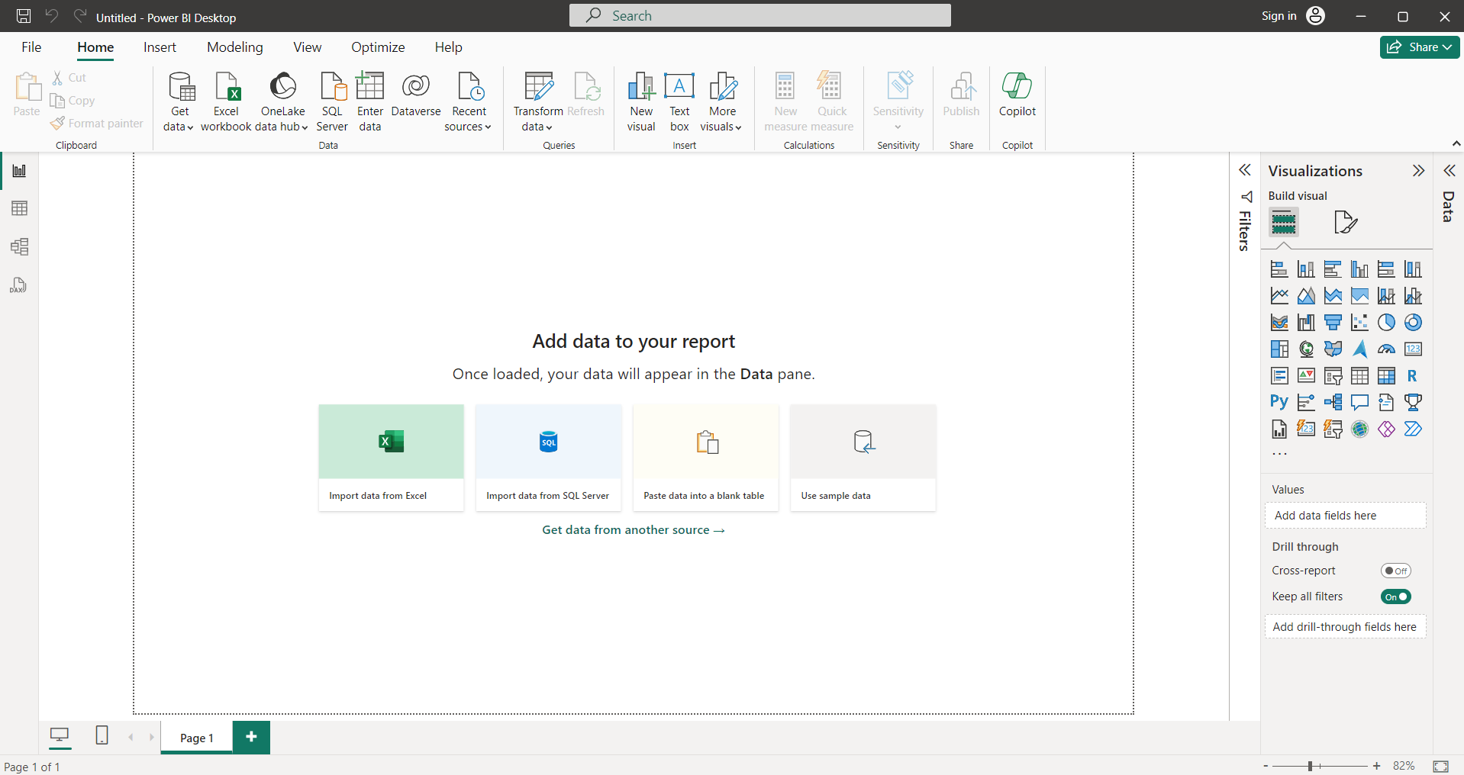

1. **Need to change the normal excel file into csv file**

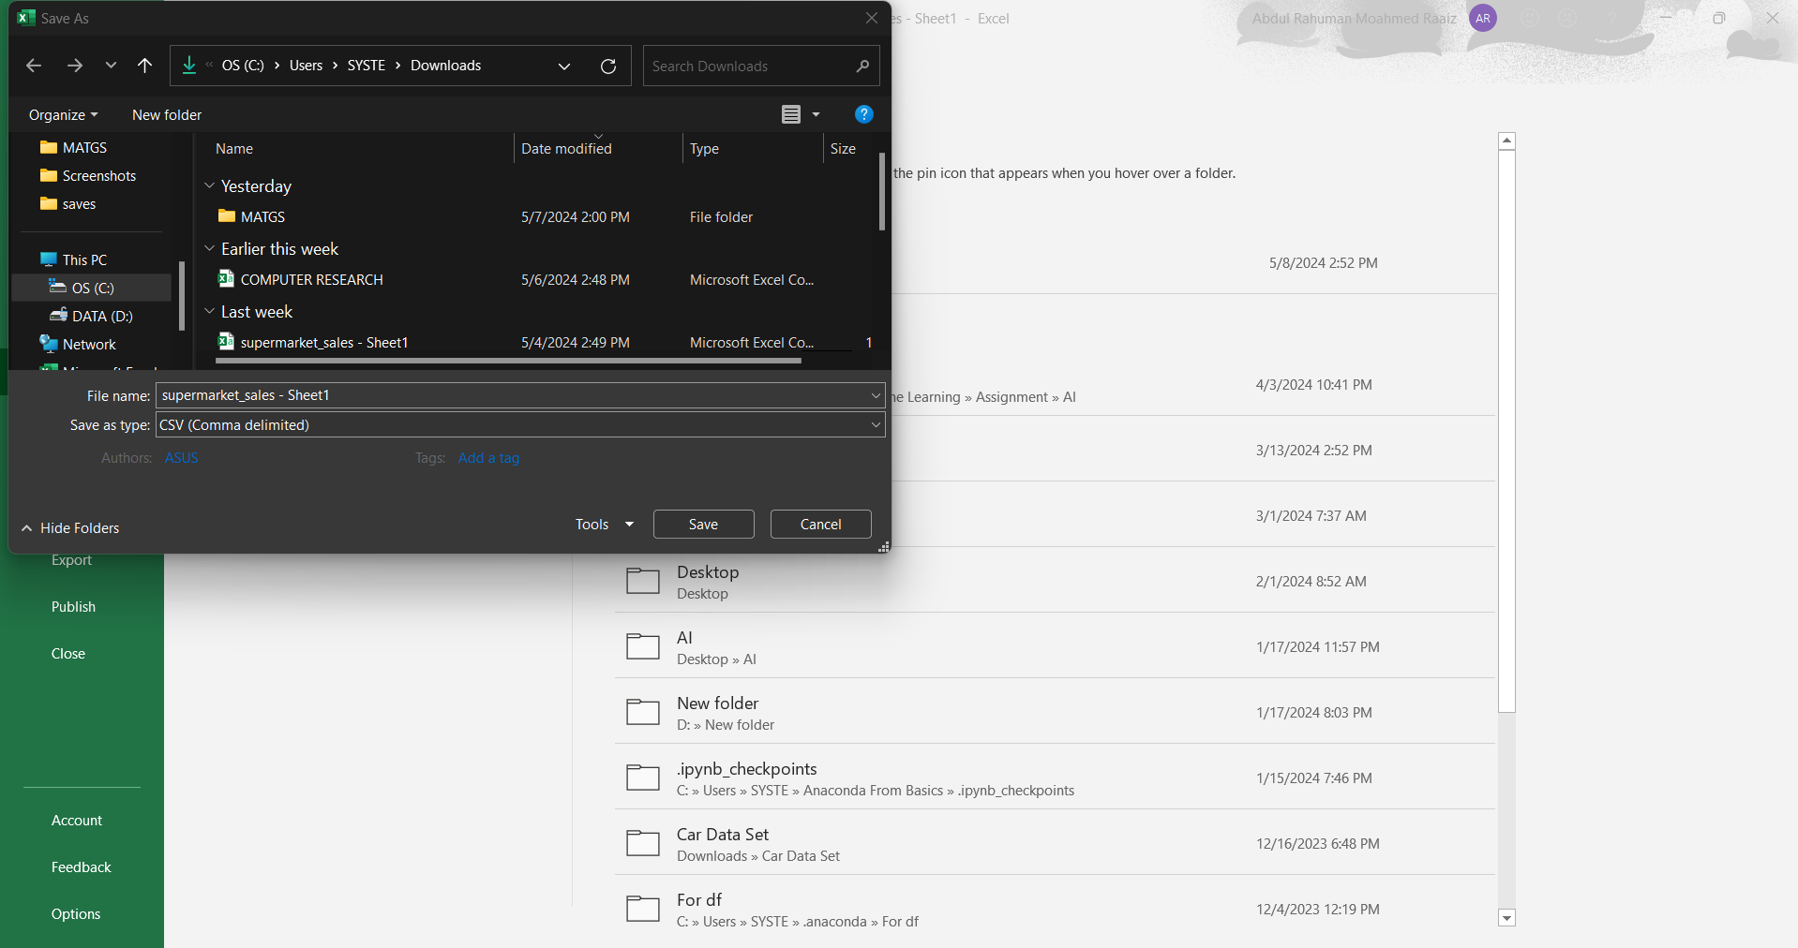

**Opting for CSV files in dashboard introduction presents countless compelling advantages:**

* + Data Accessibility: CSV files serve as a widely accessible format, enabling easy technology from a number sources such as databases or spreadsheets, making sure handy get admission to for dashboard development.
  + Simplicity and Flexibility: Their easy shape and compatibility with tools like Excel furnish simplicity in advent and manipulation, providing a bendy pathway for statistics instruction and analysis.
  + Compatibility: Nearly all data visualization tools assist CSV importation, ensuring seamless integration into dashboards except complicated records transformations.
  + Portability: CSV files' platform independence permits for trouble-free sharing and transfer across systems, advertising collaboration and dissemination of dashboard data.
  + Performance: CSV files' lightweight nature and effectivity end result in swift statistics loading and dashboard responsiveness, improving basic user experience compared to bulkier formats.

3.Inserting the CSV file into PowerBI

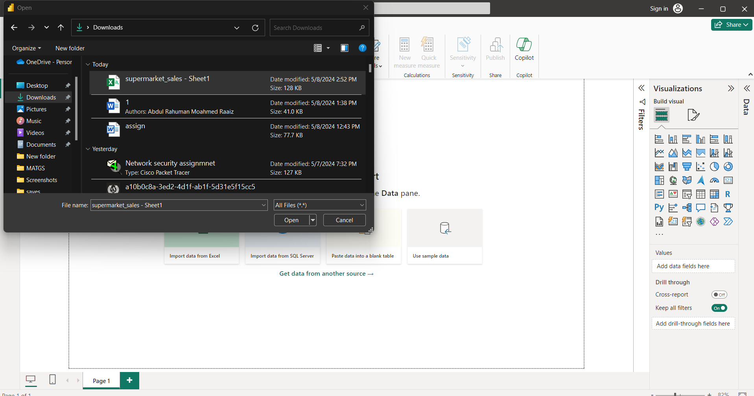

**Transform data**

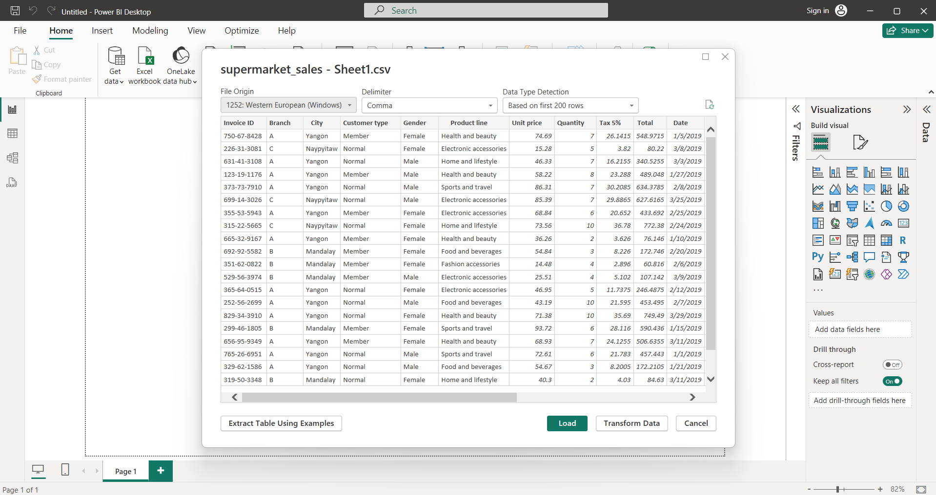

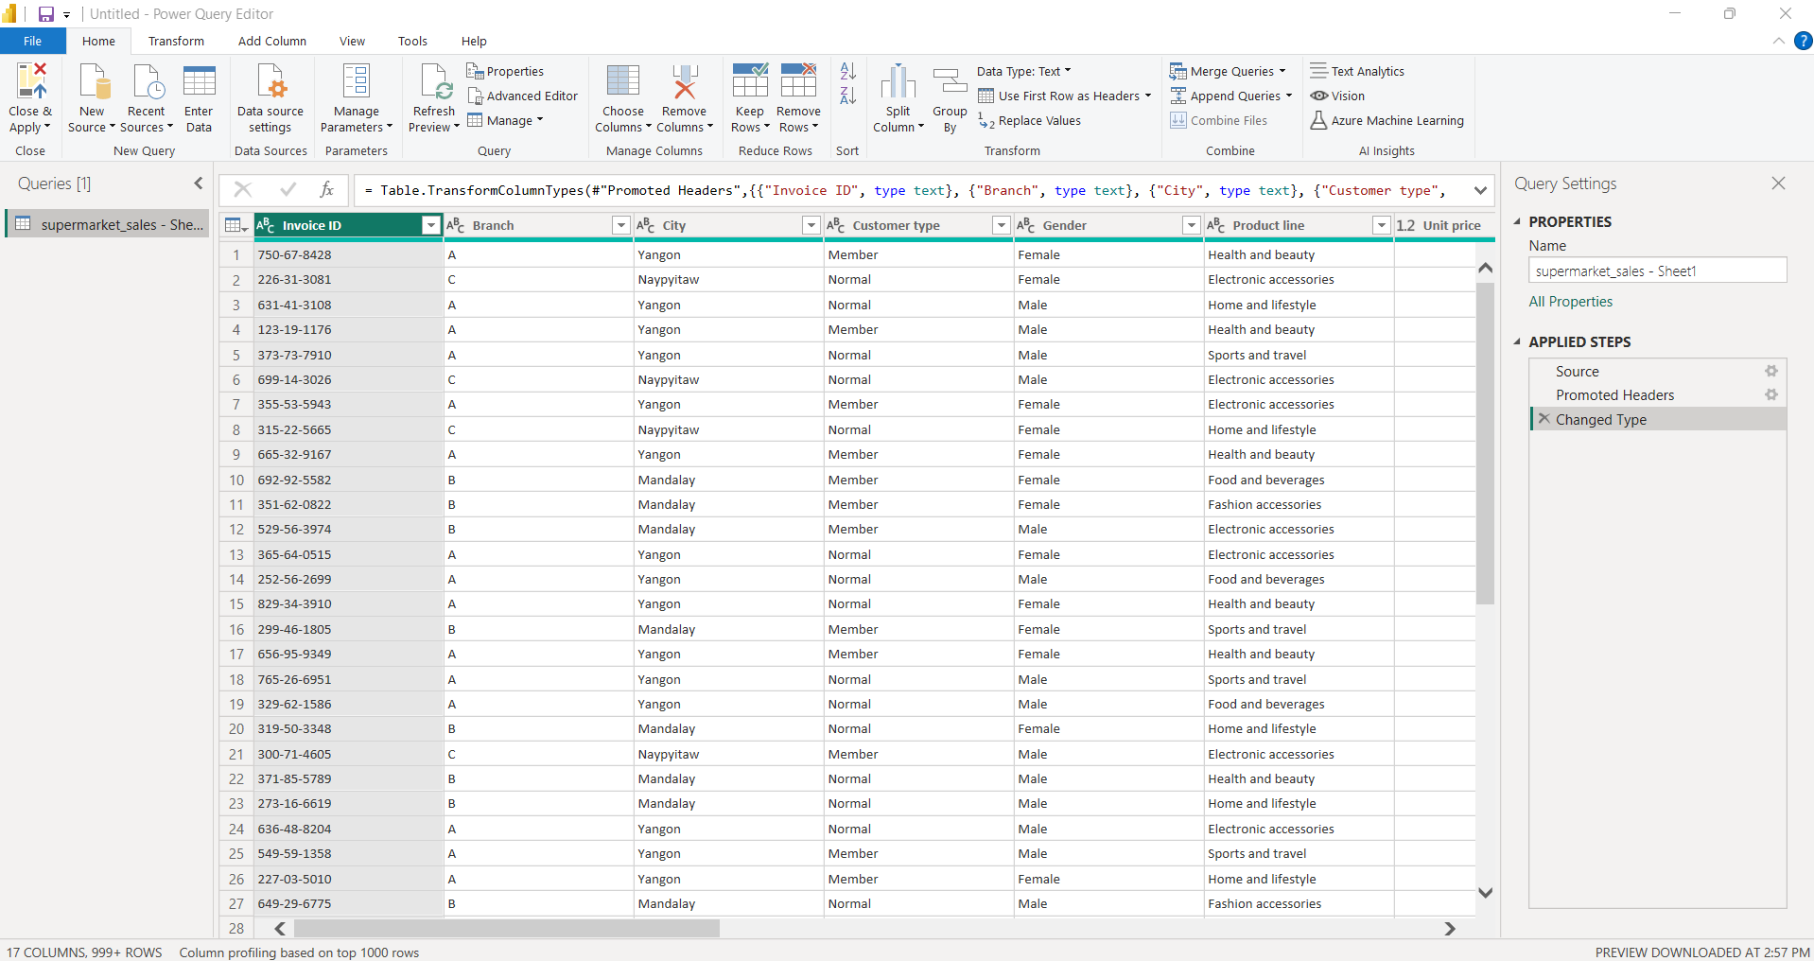

**From here onwards I need to clean the data**

**Removing the branch column**

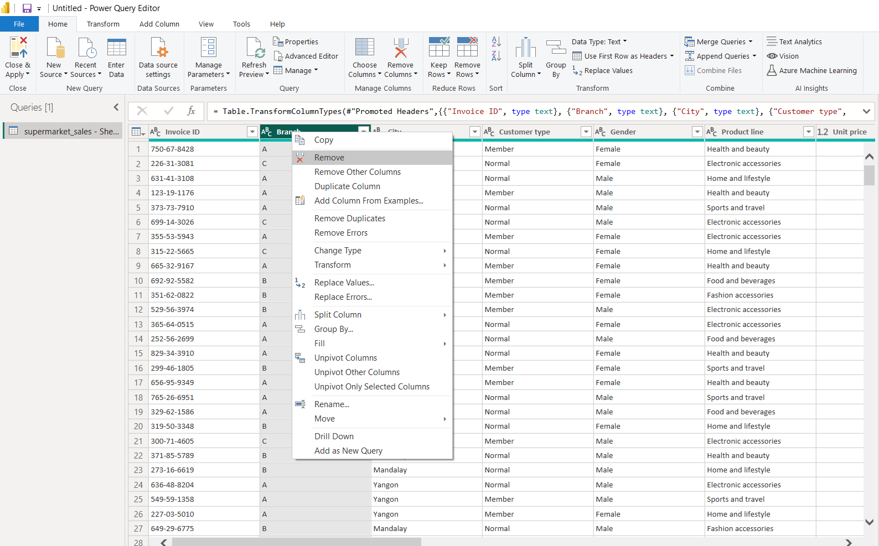

**Delete the time column**

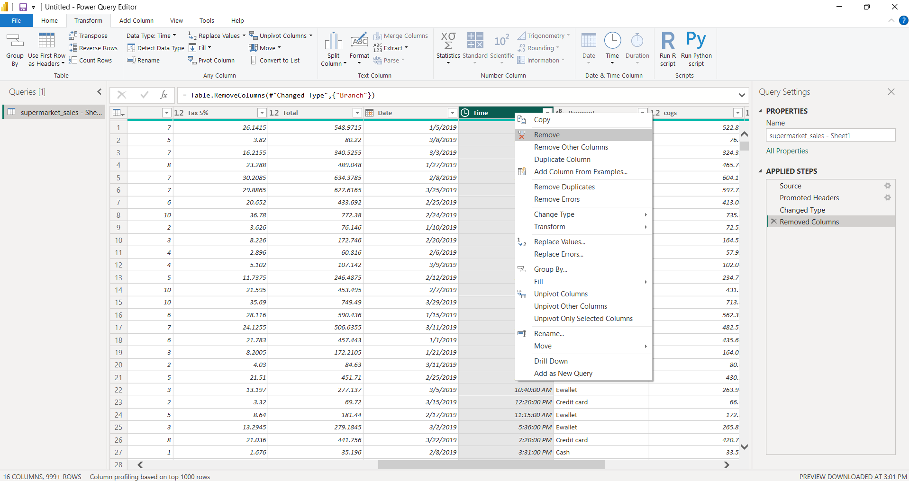

**Going to merge gross margin percentage & gross income**

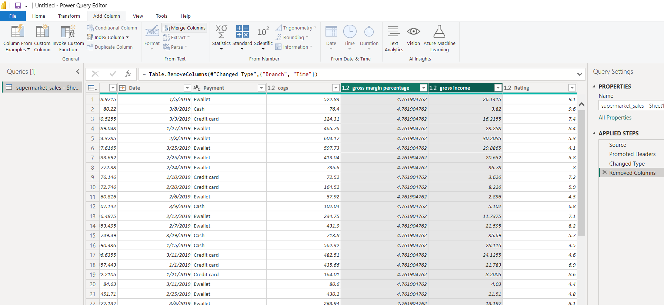

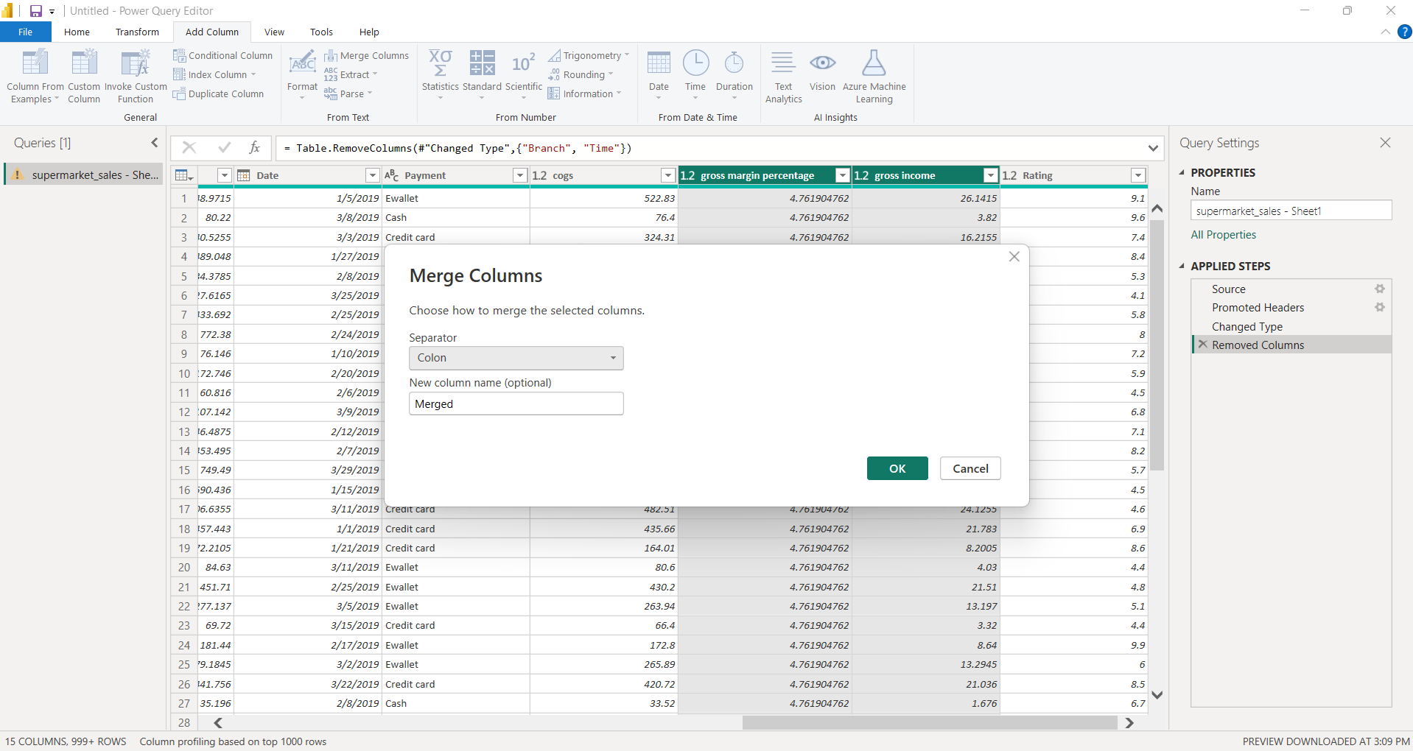

**Now going to create the dashboard**

**Need to click the close & apply**

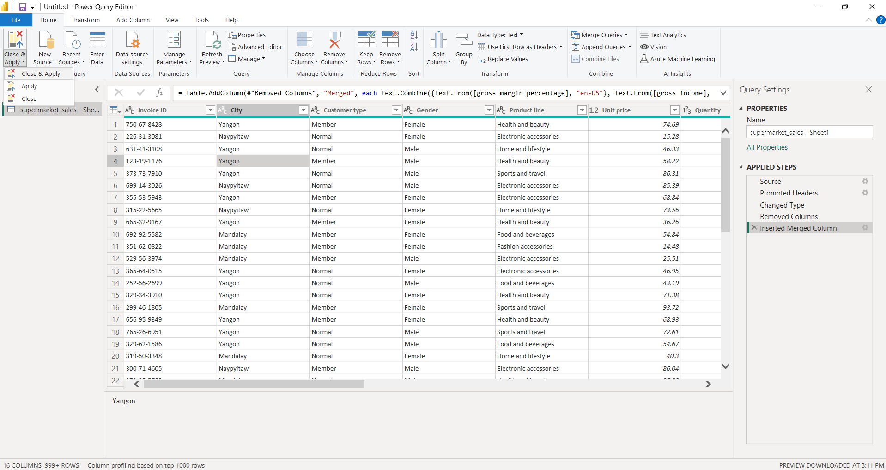

**Created the dashboard**

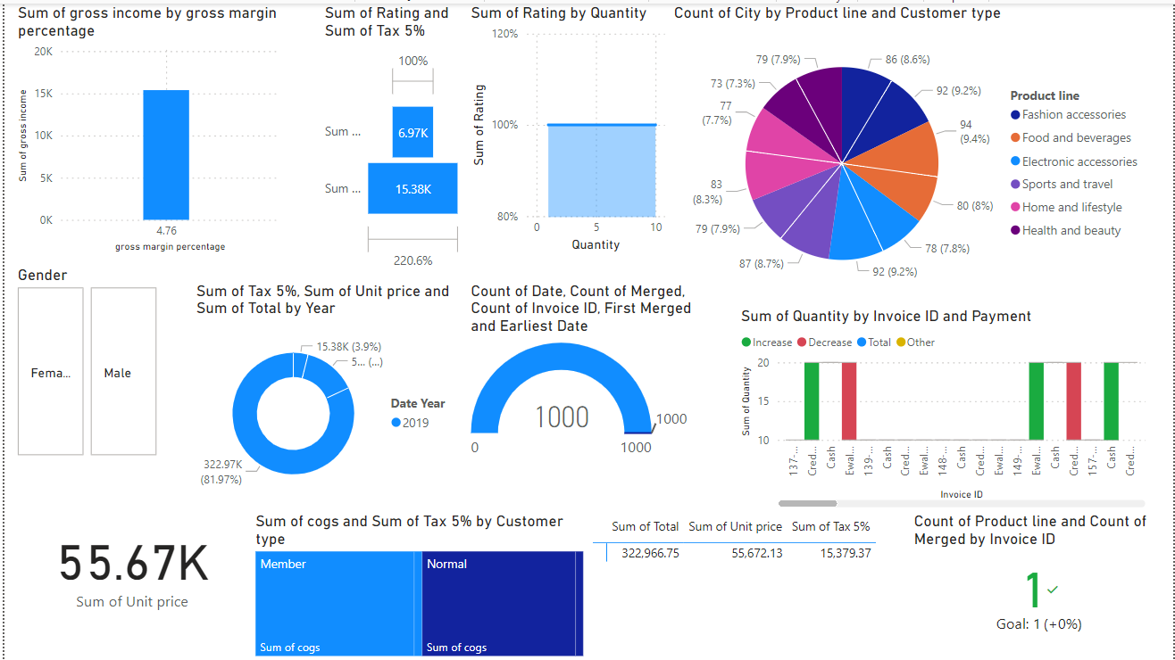

**Analyze the sales from gender**

**1.Male**

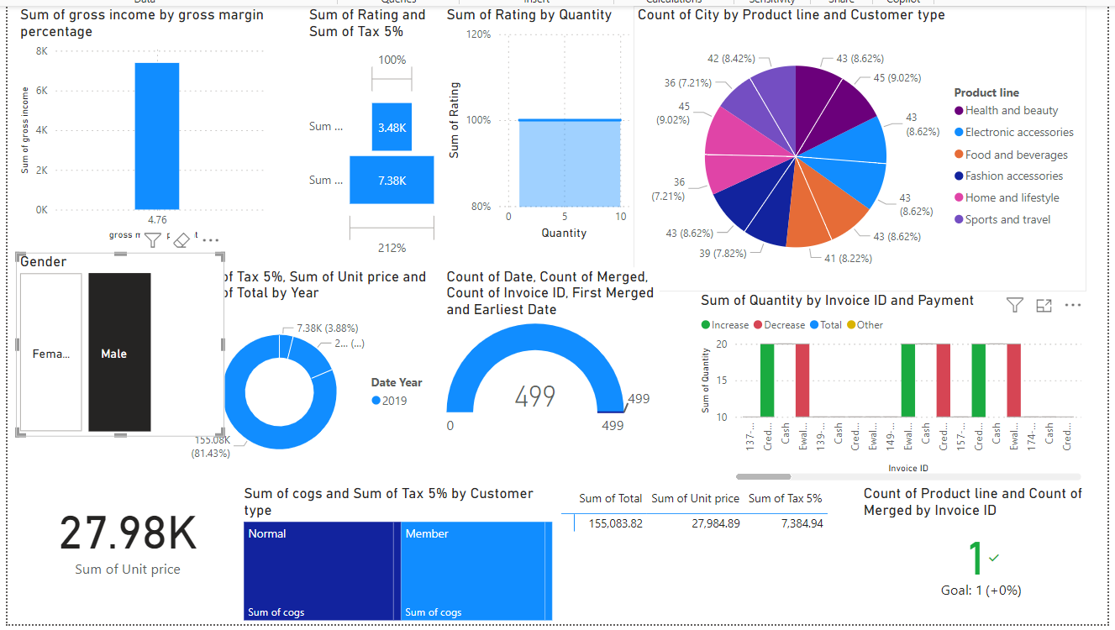

**2.Female**

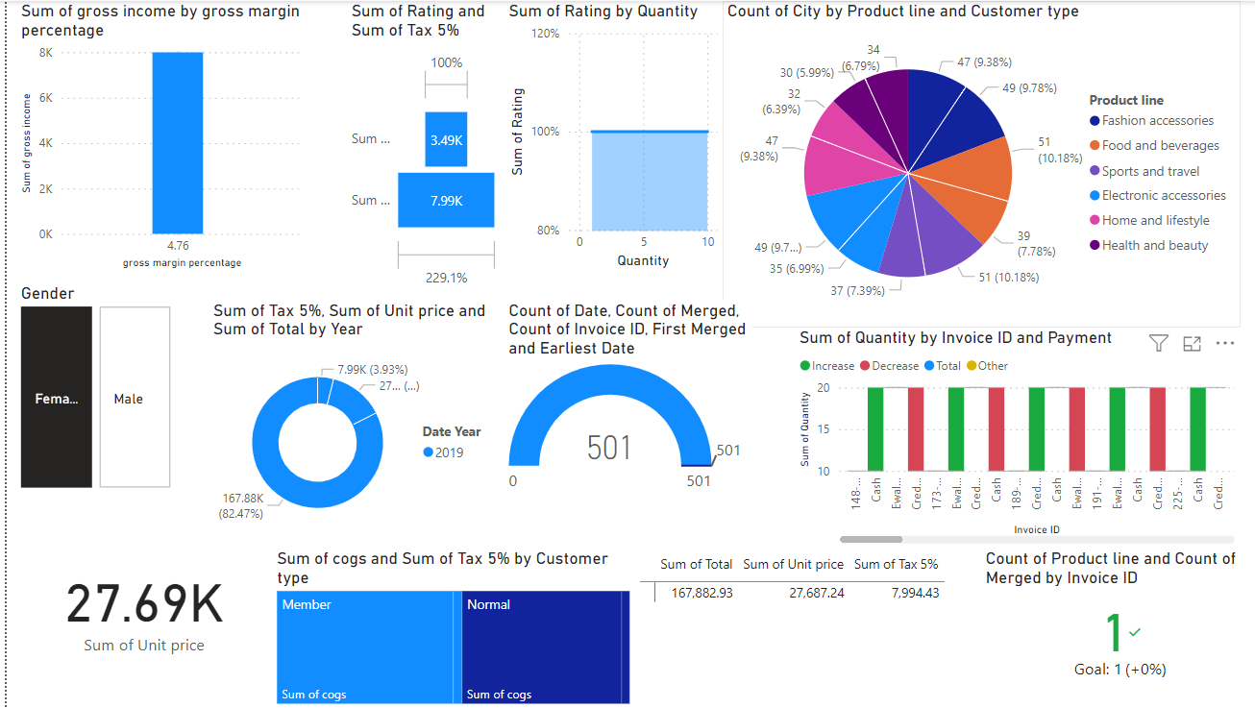

**Analyze the sales from customer type**

**Member Customer**

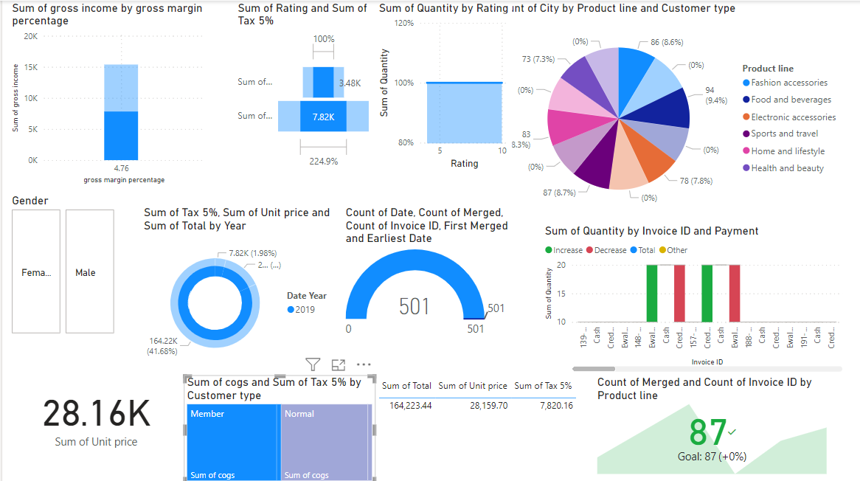

**Normal Customer**

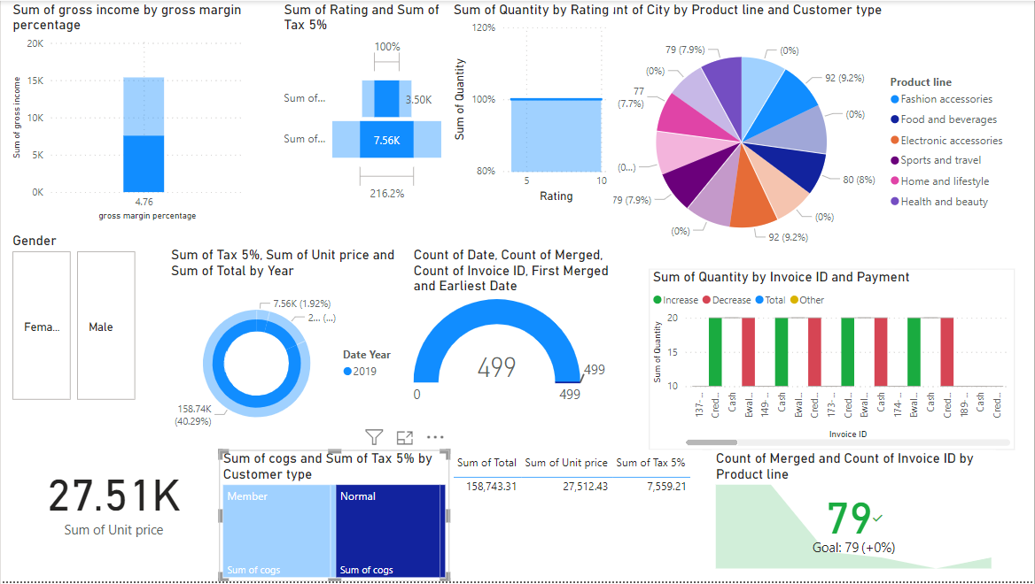

**Sales Based On The Products**

1. **Fashion Accessories**

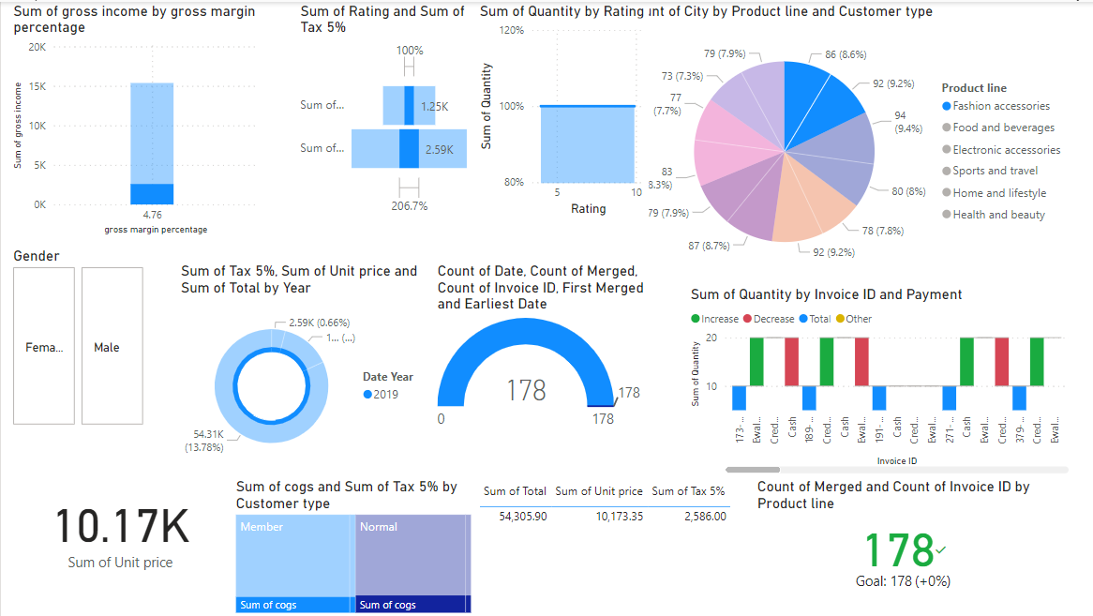

**2.Food & Beverages**

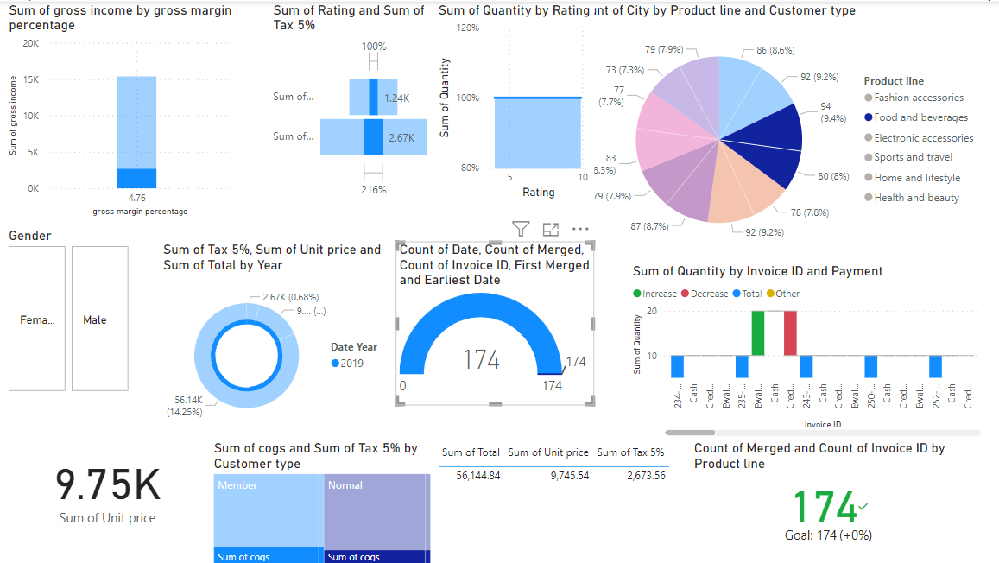

**3.Electronic Accessories**

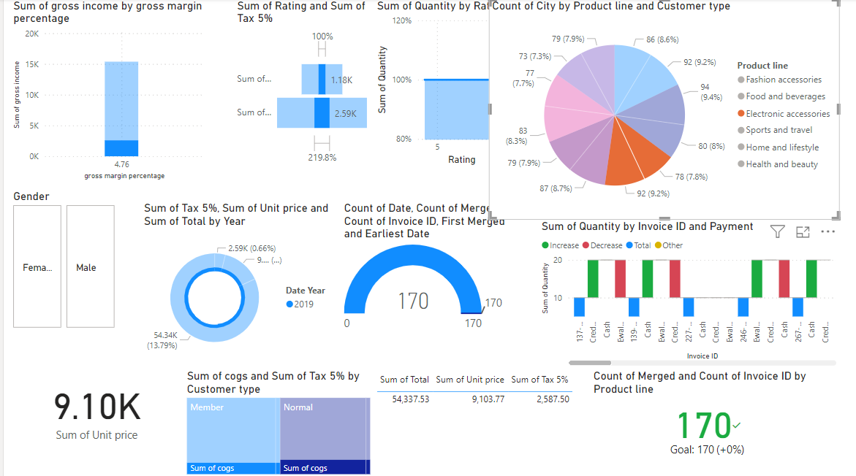

**4.Sports&Travel**

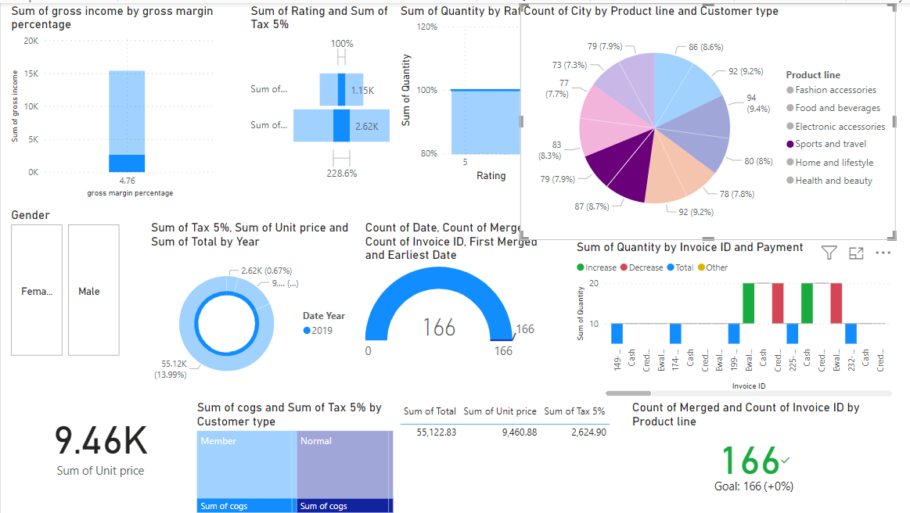

**5.Home&lifestyle**

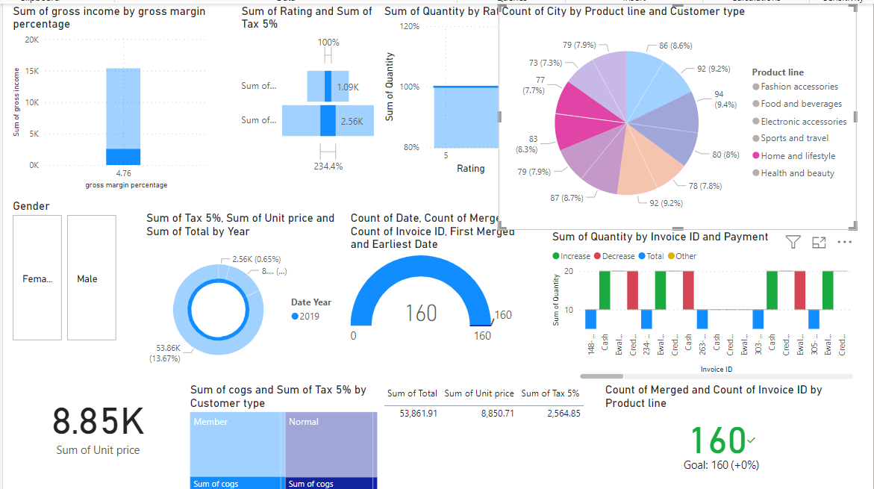

**6.Health&Beauty**

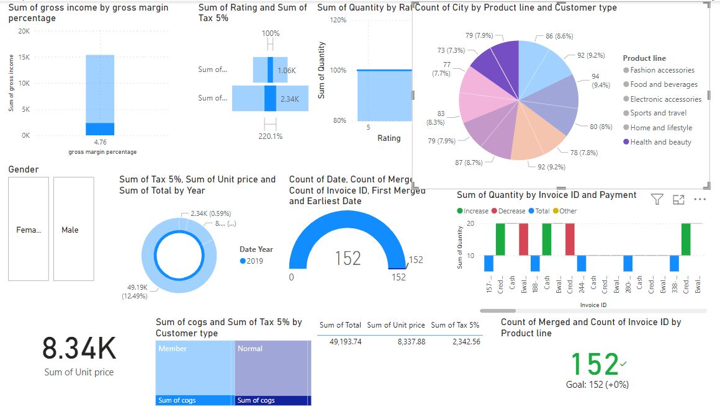

1. **By customer type**

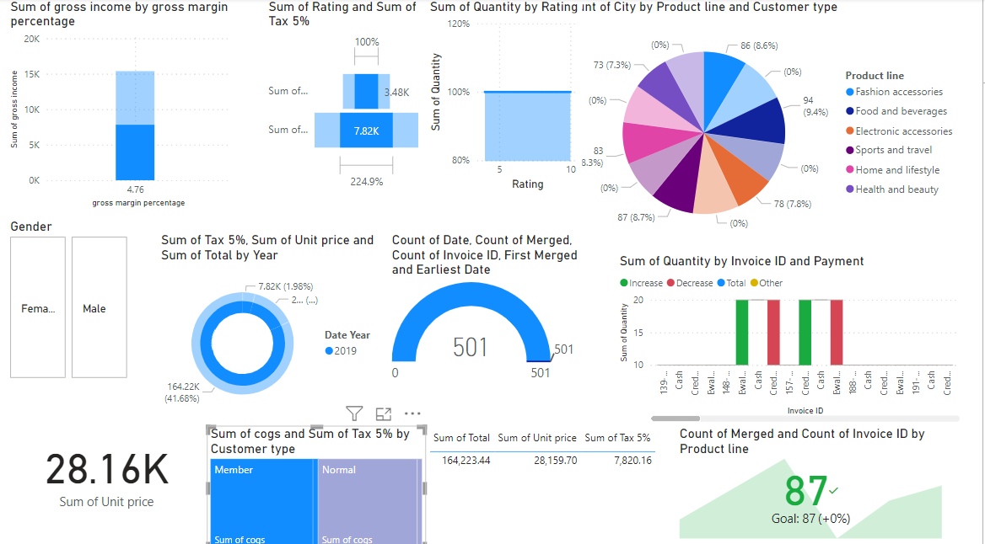

* They generate a greater share of gross income than non-member customers. This suggests that member customers are extra valuable to the business.
* They have a greater common order value than non-member customers. This ought to be due to the fact they are ordering extra merchandise or more highly-priced products.
* They may additionally be extra likely to return for repeat purchases. This is due to the fact they have a monetary incentive to do so through the membership program.

Here are some viable business selections you could make primarily based on this information:

* Invest in advertising and promotions to attract new members.
* Develop targeted advertising campaigns to motivate member clients to purchase extra frequently.
* Offer exceptional discounts or rewards to member customers.
* Analyze member consumer data to identify traits and preferences.
* Fashion accessories and electronic accessories cover sports and travel, home and lifestyle, health and beauty.

**Evidence**

**Percentage by products**

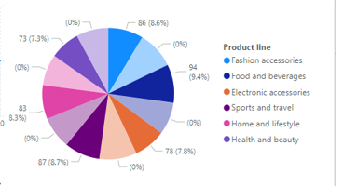

**How I took the decision**

* We made a strategic selection to allocate 50% of the provide amount to member clients for merchandise in fashion accessories, digital accessories, sports and travel, domestic and lifestyle, and health and beauty.

**This selection is grounded on the following key points:**

* Higher Value from Members: Member customers generate a greater share of gross profits and have higher average order values in contrast to non-members.
* Increased Loyalty: Members are more probable to return for repeat purchases due to the incentives provided by the membership program.

**Key Steps Taken**

* Analyzed Customer Value: Compared income, order values, and purchase frequency between participants and non-members.
* Identified Popular Categories: Focused on product categories that are popular among members.
* Formulated Promotional Strategy: Allocated 50% of the promotional budget to these high-value members.
* Targeted Marketing: Developed campaigns to inspire greater prevalent purchases by way of members.
* Leveraged Data Analytics: Analyzed member facts to tailor advertising and product development.

**Justification**

* Maximize Revenue: Investing in member customers who generate extra income.
* Enhance Loyalty: Strengthening patron retention via sizeable incentives.
* Data-Driven Strategy: Using concrete data to guide promotional efforts.
* Efficient Resource Allocation: Focusing on product classes that enchantment to members.
* This approach pursuits to capitalize on the excessive cost and loyalty of member customers, riding income increase and bettering patron loyalty.

**Decision: These facts could be used to boost new merchandise or offerings that attraction to member customers. Based on this, we are going to give 50% of the offer amount to members for these products.**

**Normal members**

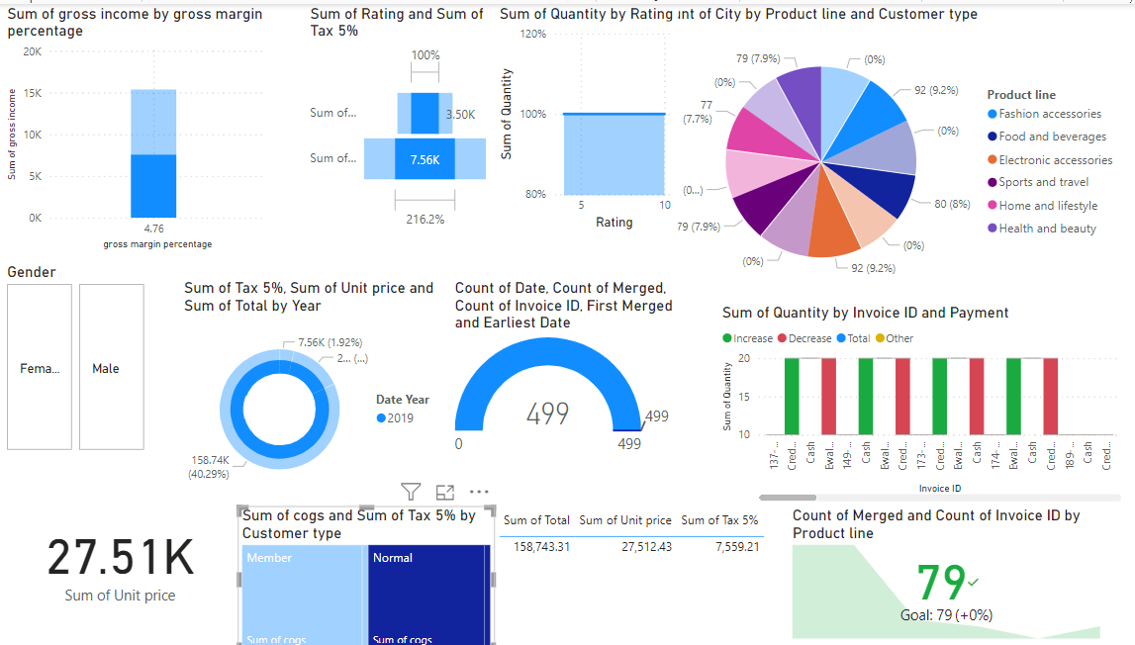

Observations about Normal Customers

* Normal clients make contributions less gross income than member customers. In the chart titled “Sum of gross profits by using Customer type,” ordinary clients account for 158,743.31 whereas member clients account for 27,512.43. This suggests that member clients are greater treasured to the business in terms of whole income generated. However, it’s vital to consider that there may additionally be more ordinary clients than member customers.
* We don’t see any records on common order cost or number of purchases for everyday customers. Without this data, it’s tough to say definitively whether or not everyday customers have a decrease common order value or purchase less frequently than member customers.

Business Decisions

* Track conversion charge from normal to member customers. The dashboard doesn’t show how many everyday clients convert to participants over time. If the conversion price is low, you may additionally prefer to check out motives why and put into effect techniques to improve it. Some thoughts encompass offering unique discounts or promotions to incentivize ordinary customers to grow to be members.
* Analyze ordinary client buy behavior. The statistics doesn’t show what products ordinary clients usually purchase. You ought to section your purchaser data to see if there are any precise product categories that ordinary customers tend to purchase extra frequently. This should help you advance focused advertising and marketing campaigns to encourage them to purchase more or turn out to be members.
* Offer a loyalty program for normal customers. A loyalty program could incentivize repeat purchases from regular clients and encourage them to spend more. You should provide points for every buy that can be redeemed for reductions or different rewards.

**How I took the decision**

1. **Observations About Normal Customers**

**Gross Income Contribution**

Normal clients make contributions less gross earnings than member customers.

The chart titled “Sum of Gross Profits by using Customer Type” suggests everyday clients account for $158,743.31, whereas member customers account for $27,512.43.

This suggests that whilst member customers are extra valuable in phrases of total earnings generated, there is viable to amplify the value from ordinary customers by changing them into members.

**Popular Product Categories**

Normal clients frequently purchase products in sports activities and travel, fitness and beauty, digital accessories, meals and beverages, and fashion.

Focusing on these categories can help goal the proper products for promotions to convert regular clients into members.

**Lack of Detailed Purchase Data**

There is no records on the average order fee or the quantity of purchases for regular customers.

This makes it difficult to determine if everyday customers have a decrease average order cost or buy less frequently than member customers, however the gross earnings statistics suggests that growing their cost thru membership ought to be beneficial.

1. **Business Decisions Based on Observations**

**Track Conversion Rate**

Monitor the fee at which normal clients convert to members after offering the discount.

If the conversion charge is low, investigate motives and regulate the incentive strategy as needed.

**Analyze Purchase Behavior**

Segment client records to pick out the purchase behavior of regular customers extra precisely.

Use this facts to refine advertising strategies and promotional affords to higher go well with their needs and preferences.

**Implement Targeted Incentives**

Offer a sizeable cut price (60%) on the first buy after becoming a member to make the membership enormously attractive.

Follow up with a 50% bargain on subsequent purchases to keep the elegance of endured membership and encourage repeat purchases.

**Steps Taken to Reach the Decision**

Evaluated Customer Value:

Analyzed the gross profits contributions of everyday vs. member customers, identifying an probability to extend revenue via converting everyday customers to members.

Identified Popular Product Categories:

Noted that everyday customers frequently purchase specific classes of products.

Decided to focal point reductions on these categories to maximize the appeal of the membership program.

Formulated Discount Strategy:

Determined that a 60% cut price on the first purchase after turning into a member would be a robust incentive for regular customers.

Decided to offer a 50% bargain on subsequent purchases to keep consumer hobby and loyalty.

Planned Conversion Monitoring:

Implemented a method to tune the conversion fee of normal customers to contributors and analyze the effectiveness of the bargain program.

Planned to adjust the method based totally on conversion fees and customer feedback.

Enhanced Loyalty Programs:

Created a compelling loyalty application to incentivize normal clients to end up members.

Focused on supplying substantial initial discounts observed via huge ongoing benefits to encourage long-term membership and extended spending.

By implementing these steps, the commercial enterprise objectives to leverage the high possible price of everyday clients through converting them into members, thereby riding revenue growth, bettering consumer loyalty, and increasing normal profitability.

**Decision: A lot of normal members buy sports and travel, health and beauty, electronic accessories, food and beverages, sports and travel, and fashion, so if they get the membership, we will give them 60% off those products for first purchase after that it will be 50% offer.**

**Additional Considerations**

* Customer Lifetime Value (CLV). It considers the complete revenue a purchaser is anticipated to generate over their relationship with the business. While the picture doesn’t supply information on CLV of ordinary clients vs. member customers, it may also be a useful metric to reflect on consideration on for a greater complete perception of consumer value.
* Customer Acquisition Costs. The value of obtaining new customers (both member and normal) need to be factored into your decisions.
* By examining patron facts and understanding the relative cost of unique patron segments, you can make knowledgeable decisions about how to goal your advertising and marketing efforts and optimize your consumer acquisition strategy.

**Evidence**

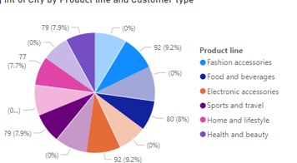**’**

**Evaluation Based on product**

**Fashion accessories**

**Evidence**

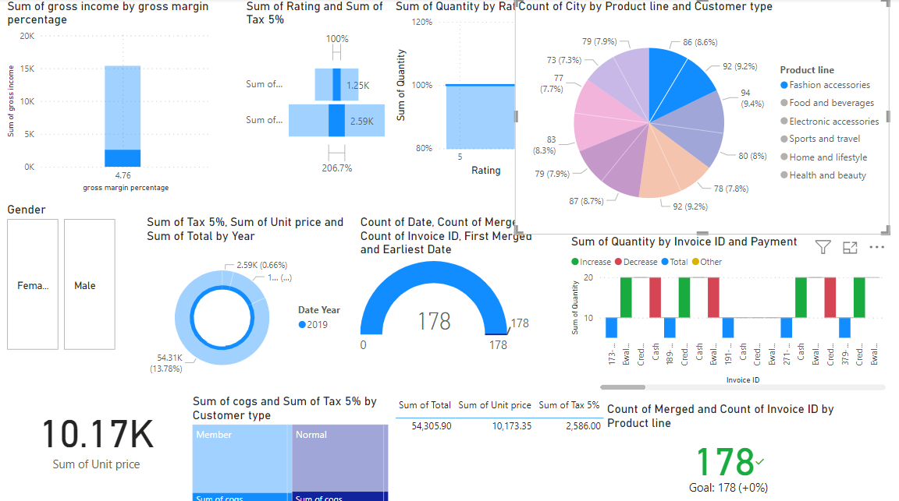

**How I took the decision**

**Fashion Accessories**

* Profitability: Looking at "Sum of gross income with the aid of product line and Customer type," fashion accessories generate less gross earnings than some other categories, like food and beverages. However, profitability isn't shown here. To investigate profitability, you would want to aspect in the cost of goods sold (COGS) for trend accessories.
* Customer Base: Normal clients appear to buy a smaller proportion of fashion accessories in contrast to member clients (7.7% vs 9.4%).

**Business Decisions**

* Increase profitability: If trend accessories have lower profitability than other product lines, you can also think about strategies to extend earnings margins. This should contain negotiating with suppliers to minimize COGS, or raising prices slightly.
* Improve conversion rate for everyday customers. As mentioned earlier, normal clients purchase a lower share of fashion accessories than member customers. You should check out reasons for this and implement techniques to improve conversion rates. Some ideas include:
* Targeted advertising and marketing campaigns for fashion add-ons aimed at regular customers.
* Offering promotions or reductions on trend add-ons for everyday customers.
* Highlighting merchandise with high margins inside trend accessories.

**Evidence**

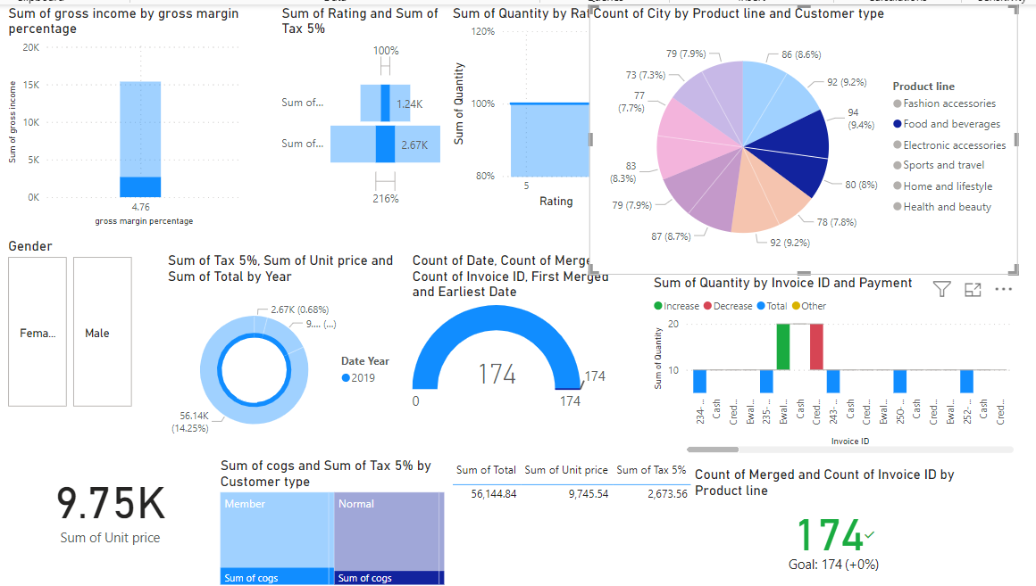

**How I took the decision**

Food and Beverages

Sales: According to the chart titled "Sum of gross earnings with the aid of product line and Customer type," meals and beverages account for the 2d best possible gross profits (2.67K) after electronic accessories (2.67K). However, it is essential to think about that the profitability can also be lower due to greater COGS (cost of goods sold) for food and beverages.

Customer Base: Member clients buy a greater share of meals and liquids in contrast to normal clients (8.6% vs 7.3%).

**Business Decisions**

Increase profitability: It can be difficult to examine profitability from this data barring understanding COGS for food and beverages. If the COGS is high, you may additionally choose to consider strategies to limit fees or elevate expenditures barely to improve profit margins.

Promote to each member and everyday customers: Food and drinks are a popular category, but there looks to be an probability to increase sales to each consumer groups. You may want to put in force strategies such as:

* Targeted marketing campaigns for food and beverages.
* Offering exceptional promotions or reductions on food and beverages.
* Bundling food and beverages with different famous products.

**Evidence**

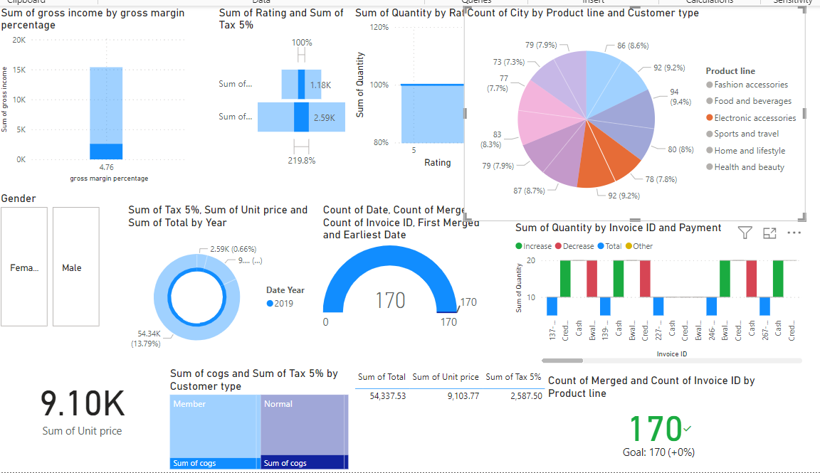

**How I took the decision**

Electronic Accessories

Sales: Electronic accessories generate the second very best gross profits (2.59K) after meals and liquids (2.67K) according to the chart titled "Sum of gross earnings by product line and Customer type."

Profitability: We cannot verify profitability from this facts barring understanding the fee of goods bought (COGS) for digital accessories.

Customer Base: The facts suggests that each member and everyday customers buy digital accessories (member: 9.4%, normal: 7.7%).

**Business Decisions**

Analyze profitability: Since digital add-ons is a top-selling category, it’s vital to recognize its profitability. You should calculate the COGS for digital add-ons to determine its earnings margin. If the profit margin is low, you may also consider strategies such as negotiating with suppliers to limit COGS or elevating expenditures slightly.

Optimize income for both customer groups: Electronic add-ons appear to be famous with each member and regular customers. You ought to enforce strategies to enlarge sales to both groups, such as:

* Targeted advertising campaigns for digital accessories.
* Offering special promotions or reductions on electronic accessories.
* Bundling digital add-ons with different popular products.

Highlighting merchandise with excessive margins inside digital accessories.

**Evidence**

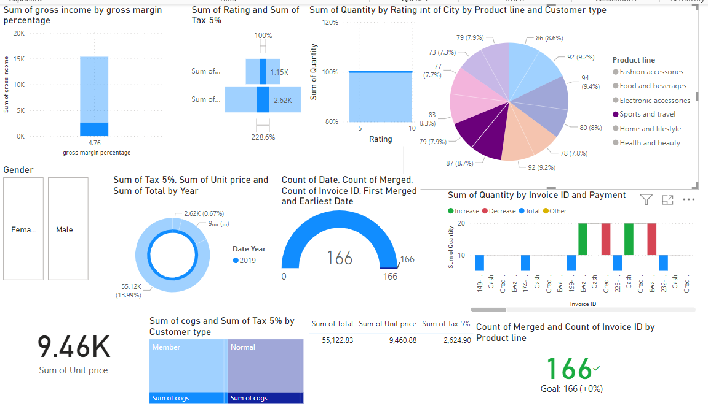

**How I took the decision**

**Sports and travel**

Sales

Lower Sales: Sports and tour appears to be the lowest grossing product line out of these listed in the chart titled “Sum of gross earnings with the aid of product line and Customer type,” contributing 80K to gross income.

Customer Base: Member clients generate a greater percentage of income in sports and journey in contrast to ordinary clients (8.3% vs 3.3%).

**Business Decisions**

Increase awareness and sales: Given that sports and travel appears to be the lowest promoting product line, you might also prefer to consider techniques to amplify brand attention and sales in this category. Here are some ideas:

* Targeted marketing campaigns to promote sports and journey products.
* Offering different reductions or promotions on sports activities and travel products.
* Bundling sports and tour products with different popular products.
* Highlighting any unique or high-margin products within sports and travel.

Focus on member customers: The statistics suggests member customers are more possibly to buy sports and tour products. You may want to tailor advertising and marketing campaigns to target member customers who have shown hobby in these classes in the past.

**Evidence**

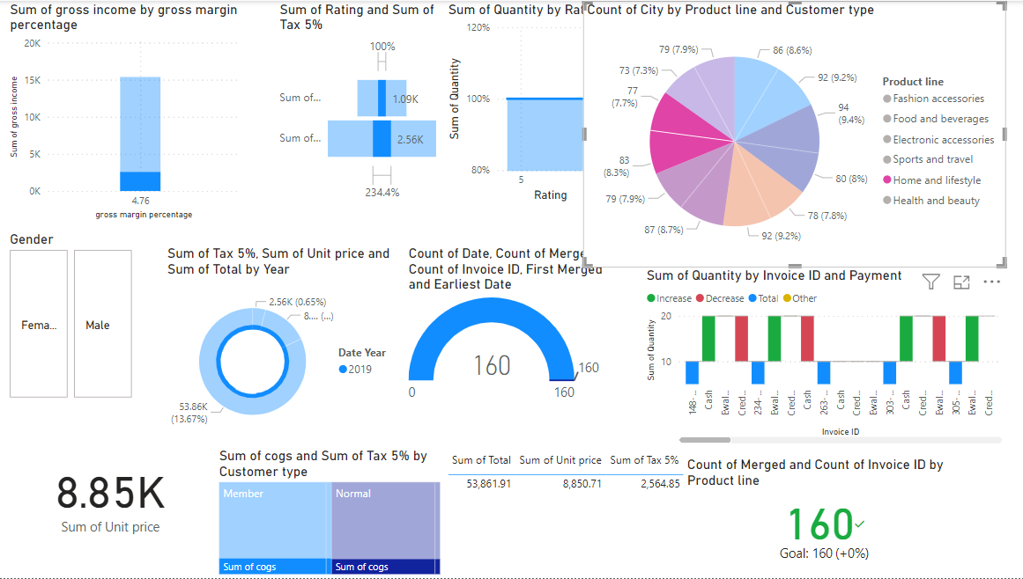

**How I took the decision**

Home and lifestyle

Sales

Lower Sales: Home and way of life seems to be the second-lowest grossing product line out of these listed in the chart titled “Sum of gross profits by way of product line and Customer type,” contributing only 80K to gross income.

Customer Base: Member customers generate a higher share of sales in home and way of life compared to normal customers (8.7% vs 6%).

**Business Decisions**

Increase attention and sales: Given that home and lifestyle appear to be one of the lower-selling product lines, you may additionally favor to reflect on consideration on techniques to increase manufacturer focus and sales in this category. Here are some ideas:

* Targeted advertising and marketing campaigns to promote home and life-style products.
* Offering specific reductions or promotions on domestic and life-style products.
* Bundling domestic and way of life products with other famous products.
* Highlighting any special or high-margin merchandise inside home and lifestyle.

Focus on member customers: The records suggest member clients are more probable to purchase domestic and lifestyle products. You may want to tailor advertising campaigns to target member customers who have proven pastime in these categories in the past.

**Evidence**

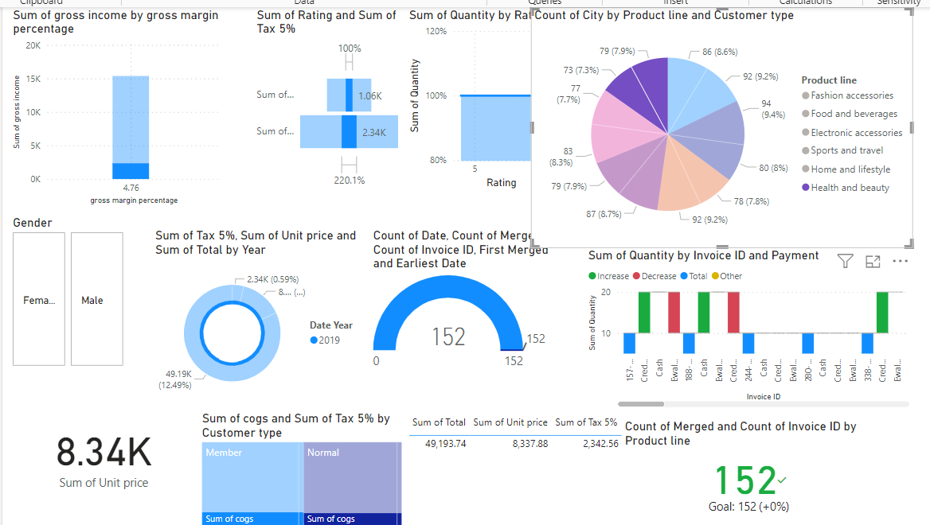

**How I took the decision**

**Sales**

Sales Performance: It appears health and beauty is the fourth best possible grossing product line out of these listed in the chart titled "Sum of gross income through product line and Customer type," contributing 4.76K to gross income. Without data on different product lines, it’s challenging to say how health and beauty compares in standard sales performance.

Customer Base: Member clients generate a higher proportion of income in fitness and beauty compared to normal customers (7.8% vs. 5.7%).

**Business Decisions**

Analyze profitability: While health and beauty generate a decent quantity of gross income, profitability isn't always proven here. To verify profitability, you would want to issue in the value of goods sold (COGS) for fitness and splendor products.

Grow sales: Here are some thoughts to grow income in health and beauty, especially thinking about the greater consumer base among members:

* Targeted advertising campaigns for health and splendor products.
* Offering exclusive discounts or promotions on health and splendor products.
* Bundling health and splendor products with different famous products.
* Highlighting any special or high-margin merchandise inside fitness and beauty.

Focus on member customers: The data suggests member customers are more possibly to purchase health and splendor products. You ought to tailor advertising campaigns to target member customers who have shown activity in these categories in the past.

**Enhancing Dashboard Components:**

* Improving income overview to detect revenue patterns and perceive top-performing product categories.
* Advancing sales traits evaluation to find income fluctuations and determine good sized sales contributors.
* Enhancing purchaser insights to recognize demographic composition and popular products amongst specific customer segments.
* Elevating customer demographic analysis to attain deeper insights into purchaser composition and product preferences.
* Strengthening stock administration to make certain ideal inventory degrees and prioritize restocking efforts.
* Advancing stock monitoring to stop stockouts and successfully manipulate inventory replenishment.
* Optimizing promotion effectiveness evaluation to evaluate the affect of promotions and examine marketing campaign effectiveness.
* Enhancing promotional have an effect on evaluation to gauge the effectiveness of marketing strategies and promotional activities.
* Refining shop performance visualization to discover high-performing and low-performing shops and track key performance indicators (KPIs).’
* Lifting save execution perception to pinpoint shop generally execution versions and uncover fundamental KPIs.

**Implementing Customizations and Improvements:**

* Presenting intuitive perspectives like channels, drill-down choices, and tooltips to decorate records investigation.
* Consolidating intelligent functionalities like channels and tooltips to enhance Data investigation capacities.
* Empowering convenient notices for partners with the guide of setting up Data alarms for impressive measurement changes, advancement proactive navigation.
* Conveying ready components to rapidly advise partners regarding magnificent metric variances, working with proactive direction.
* Upgrading dashboard clearness and ease of use through decisively orchestrating gadgets and gathering related perceptions.
* Further developing dashboard clarity and buyer trip through sensible gadget position and perception order.
* Maintaining visual coherence throughout the dashboard by using a constant color palette.
* Ensuring visual uniformity by using a standardized color scheme across all dashboard components.
* Enhancing statistics interpretation with the aid of incorporating annotations to highlight vital insights, trends, or anomalies.
* Utilizing annotations to underscore noteworthy records findings, trends, or irregularities, fostering deeper contextual understanding.
* Improving dashboard overall performance through minimizing statistics refresh times and simplifying visualizations for a smoother user experience.
* Enhancing dashboard performance by decreasing statistics refresh intervals and simplifying visualizations to make sure most beneficial consumer experience.
* Ensuring accessibility to all customers with the aid of adhering to design excellent practices, including suited contrast ratios and display screen reader compatibility.
* Guaranteeing dashboard accessibility through following sketch nice practices, such as preserving suitable contrast ratios and compatibility with display screen readers.
* Through these enhancements and optimizations, the managerial dashboard will become a potent tool, empowering stakeholders with actionable insights and riding operational effectivity within the grocery store chain.

## 2.4. Present your design of a data science solution to support decision making in relation to real-world problem faced by the selected organization, assessing the benefits of using data to solve problems in practice.

**Data Science Solution:**

**Problem Statement:**

The selected organization, a supermarket chain, grapples with decision-making challenges due to the absence of centralized statistics analysis capabilities. These challenges manifest as inefficient useful resource allocation, ineffective promotion strategies, and insufficient performance monitoring across its stores.

**Data Integration:**

Gather Data from various sources, together with income transactions, customer demographics, inventory levels, promotional activities, and shop overall performance metrics.

Consolidate the gathered records into a centralized Data warehouse or platform for streamlined analysis.

**Data Preprocessing:**

Cleanse and preprocess the gathered Data to address problems like lacking values, duplicates, and inconsistencies.

Conduct statistics transformation and function engineering to extract significant insights from the uncooked data.

**Exploratory Data Analysis (EDA):**

Perform exploratory Data analysis to uncover underlying patterns, trends, and correlations inside the dataset.

Visualize key metrics such as sales trends, patron behavior, inventory levels, and promotional effectiveness to achieve deeper insights.

**Predictive Modeling:**

Develop predictive fashions to forecast sales, section customers, optimize inventory levels, and examine advertising effectiveness.

Apply desktop studying algorithms such as regression, classification, and clustering to construct predictive models based on historic data.

**Dashboard Development:**

Create a managerial dashboard using visualization tools like Power BI or Tableau to speak actionable insights derived from the data.

Incorporate interactive visualizations and key overall performance indicators (KPIs) associated to income performance, consumer demographics, inventory management, promoting effectiveness, and shop performance.

**Explanation:**

The proposed Data science solution addresses the organization's decision-making challenges by leveraging Data integration, preprocessing, exploratory statistics analysis, predictive modeling, and dashboard development. By gathering data from multiple sources and centralizing it for analysis, the organization can gain a complete view of its operations. Data preprocessing ensures the data's nice and relevance, while exploratory records evaluation uncovers treasured insights. Predictive modeling permits the organization to forecast future developments and make proactive decisions, whilst the managerial dashboard gives a basic interface for having access to actionable insights. Through these components, the company can overcome its decision-making barriers and pressure effectivity and effectiveness across its stores.

**Benefits of Using Data to Solve Problems:**

1. **Informed Decision-Making:**

Data-driven insights empower decision-makers by way of presenting them with a holistic perception of integral factors such as aid allocation, promotional strategies, and average shop operations. This comprehensive data serves as the foundation for strategic decision-making, enabling stakeholders to make well-informed preferences that align with organizational desires and objectives.

Utilizing predictive fashions enhances decision-making competencies with the aid of enabling the anticipation of future tendencies and outcomes. Through the evaluation of historic facts and the utility of superior algorithms, predictive fashions facilitate the prediction of sales patterns, optimization of stock levels, and evaluation of advertising effectiveness. As a result, decision-makers are equipped to make proactive choices that lead to extra favorable outcomes and extended operational efficiency.

**Meaningful Decisions**

* Comprehensive Insights: Data-driven insights furnish decision-makers with a holistic view of key elements such as aid allocation, promotional strategies, and typical shop operations. This comprehensive data varieties the basis for strategic decision-making, enabling selections that align with organizational goals and objectives.
* Predictive Models: Utilizing predictive models enhances decision-making capabilities via forecasting future traits and outcomes. By examining historic facts and applying advanced algorithms, corporations can predict sales patterns, optimize inventory levels, and evaluate advertising and marketing effectiveness. This foresight permits for proactive selections that lead to greater favorable effects and extended operational efficiency.

1. **Improved Operational Efficiency:**

Harnessing insights derived from data optimizes aid allocation processes, successfully addressing challenges such as stockouts, excess inventory, and inefficient promotional strategies. By leveraging data-driven analysis, organizations can streamline operations, allocate resources greater efficiently, and reduce wastage, subsequently improving operational efficiency and lowering costs.

Real-time monitoring of performance enables stakeholders to unexpectedly identify areas of enchancment and address operational bottlenecks. By constantly monitoring key performance warning signs (KPIs) and overall performance metrics, agencies can proactively discover underperforming shops or processes, enabling timely interventions and fostering a culture of non-stop improvement. This proactive method to overall performance monitoring enhances operational efficiency and drives overall organizational success.

**Meaningful Decisions**

* Optimized Resource Allocation: Insights derived from facts optimize useful resource allocation, efficiently addressing challenges like stockouts, excess inventory, and inefficient promotional strategies. Data-driven analysis helps streamline operations, allocate resources extra efficiently, and reduce wastage, thereby enhancing operational effectivity and lowering costs.
* Real-Time Performance Monitoring: Continuous monitoring of key performance symptoms (KPIs) and performance metrics permits stakeholders to rapidly pick out areas for improvement and address operational bottlenecks. This proactive method to performance monitoring fosters a tradition of continuous improvement, bettering operational effectivity and using overall organizational success.

1. **Enhanced Customer Experience:**

Employing data-driven methodologies lets in organizations to tailor marketing processes and product offerings to precise client segments, enhancing standard client pleasure and loyalty. By examining patron records and preferences, businesses can customize advertising campaigns and product recommendations, developing a extra personalized and enticing buying ride for customers.

Data-centric decision-making ensures that corporations align their strategies with evolving consumer preferences and requirements. By utilizing empirical records to draw close client conduct and preferences, companies can tailor their choices and services to align with evolving consumer needs, subsequently fostering a buying ecosystem marked through personalized experiences and nurturing enduring consumer loyalty.

**Meaningful decision**

* Tailored Marketing Strategies: Data-driven methodologies allow corporations to tailor advertising tactics and product choices to unique patron segments, bettering basic client delight and loyalty. By examining customer facts and preferences, companies can create customized advertising campaigns and product recommendations, ensuing in a greater enticing and pleasurable buying experience.
* Alignment with Customer Preferences: Data-centric decision-making ensures that corporations align their techniques with evolving patron preferences and requirements. By appreciation client conduct and preferences through empirical data, groups can tailor their offerings and services to meet evolving needs, fostering a buying ecosystem characterized through customized experiences and nurturing enduring patron loyalty.

**Justification of Recommendations:**

1. **Data Integration:**

Issue: The company faces challenges with numerous facts sources and lacks a centralized platform for complete analysis.

Rationale: Consolidating data from a number sources into a centralized platform allows complete analysis, presenting stakeholders with a unified perspective on crucial metrics such as sales, inventory, and patron behavior. This integration enables deeper insights and enables more knowledgeable decision-making.

1. **Data Preprocessing:**

Issue: Data satisfactory issues, such as missing values and inconsistencies, hinder the era of meaningful Issue: Data excellent concerns, along with lacking values and inconsistencies, obstruct the technology of significant insights.

Rationale: Implementing Data preprocessing strategies addresses facts high-quality troubles by way of correcting inaccuracies and making sure the reliability of analysis results. Through cleansing and transformation, data becomes trustworthy, instilling confidence in the insights derived for strategic decision-making.

1. **Exploratory Data Analysis (EDA):**

Issue: Limited understanding of underlying facts patterns and correlations inhibits high-quality decision-making.

Rationale: EDA performs a pivotal role through illuminating insights into data, unveiling trends, outliers, and relationships integral for strategic planning. Visualizations serve as interpretable aids, simplifying complex data and facilitating actionable insights for stakeholders.

1. **Predictive Modeling:**

Issue: The enterprise struggles to foresee future trends and outcomes, ensuing in suboptimal useful resource allocation and promotional strategies.

Rationale: Predictive models offer a proactive solution through forecasting sales, customer behavior, and stock demand. By leveraging historical data, stakeholders acquire the capacity to optimize operations and enhance profitability through data-driven decision-making.

1. **Dashboard Development:**

Issue: Inadequate real-time access to key overall performance metrics impedes performance monitoring and decision-making.

Rationale: Dashboard development addresses this venture by using enabling real-time monitoring of KPIs and performance metrics. Through interactive visualizations, stakeholders achieve instant access to actionable insights, facilitating knowledgeable decision-making and enhancing organizational agility.

Overall, the pointers for implementing a Data science answer are justified as they without delay address the organization's facts management, decision-making, and overall performance monitoring challenges. Leveraging facts science strategies empowers the agency to absolutely leverage its facts assets, fostering operational efficiency and driving commercial enterprise growth.

## 2.5Assessing the Benefits of Using Data Science to Solve Problems in Real-World Scenarios

Data science presents a transformative method to solving issues throughout various industries. By leveraging advanced analytics, computing device learning, and data-driven methodologies, organizations can acquire great upgrades in decision-making, operational efficiency, consumer satisfaction, and normal commercial enterprise performance. Here are some key benefits of the usage of data science in real-world scenarios:

**1. Informed Decision-Making**

Data-Driven Insights: Data science allows agencies to make decisions based totally on empirical records as a substitute than intuition. By inspecting historical statistics and cutting-edge trends, decision-makers can become aware of patterns and correlations that provide actionable insights.

Predictive Analytics: Forecasting future traits and behaviors helps corporations put together for potential scenarios. Predictive models can forecast sales, client behavior, and market trends, allowing companies to make proactive and strategic decisions.

**2. Improved Operational Efficiency**

Resource Optimization: Data science helps in optimizing the allocation of sources such as inventory, workforce, and capital. By inspecting utilization patterns and demand, companies can decrease waste, prevent stockouts, and ensure efficient utilization of resources.

Process Automation: Machine getting to know algorithms can automate routine tasks, such as data entry, client service interactions, and anomaly detection. This reduces the need for guide intervention, speeds up processes, and minimizes human error.

**3. Enhanced Customer Experience**

Personalization: Analyzing customer facts lets in companies to tailor their products, services, and advertising and marketing efforts to person preferences. Personalized experiences lead to greater customer satisfaction and loyalty.

Customer Segmentation: By segmenting clients primarily based on behavior, demographics, and buy history, agencies can target specific corporations with personalized affords and promotions, increasing the effectiveness of advertising campaigns.

**4. Competitive Advantage**

Market Analysis: Data science gives insights into market dynamics, competitor strategies, and purchaser trends. This information permits agencies to remain ahead of the competition with the aid of adapting quickly to modifications and identifying new opportunities.

Innovation: Identifying gaps in the market and emerging traits can force innovation in product improvement and carrier offerings, supporting agencies to remain applicable and competitive.

**5. Risk Management**

Fraud Detection: Advanced analytics can detect fraudulent activities by identifying uncommon patterns and anomalies in transaction data. This protects corporations from full-size monetary losses and reputational damage.

Predictive Maintenance: For industries relying on machinery and equipment, predictive protection fashions can forecast tools disasters and time table well timed maintenance, decreasing downtime and restore costs.

**6. Cost Reduction**

Efficiency Gains: Data-driven optimization of methods and aid allocation leads to substantial price savings. By decreasing waste, minimizing excess inventory, and streamlining operations, groups can lower operational costs.

Strategic Pricing: Analyzing market traits and purchaser conduct helps groups to set aggressive prices that maximize income without sacrificing patron satisfaction.

**7. Enhanced Product and Service Development**

Customer Feedback Analysis: By examining customer comments and reviews, groups can improve current merchandise and improve new ones that higher meet purchaser needs.

Prototype Testing: Data science strategies can simulate and check new products or offerings before full-scale launch, ensuring they meet overall performance standards and patron expectations.

**8. Strategic Planning**

Scenario Analysis: Data science permits groups to run more than a few eventualities and models to apprehend doable outcomes and make informed strategic plans.

Performance Metrics: Continuous tracking and analysis of key overall performance indications (KPIs) provide a clear photograph of organizational performance and areas that want improvement.

Conclusion

The advantages of the usage of facts science to solve real-world issues are considerable and impactful. By leveraging data-driven methodologies, businesses can enhance decision-making, improve operational efficiency, supply most useful customer experiences, gain competitive advantages, control dangers effectively, minimize costs, and foster innovation. The comprehensive analysis and predictive competencies of records science empower corporations to navigate complicated challenges, capitalize on new opportunities, and attain sustainable boom and success.

## 2.6.Critically evaluate your findings on Dashboard and suggested enhancement could optimize performance by delivering accurate and reliable Data to increase his effectiveness.

**Dashboard Findings Evaluation:**

* The preliminary evaluation of the dashboard exhibits various strengths. Firstly, it effectively addresses the organization's requirement for centralized facts evaluation and decision support. This centralized method streamlines operations with the aid of offering a single supply of truth, bettering collaboration, and aligning stakeholders' grasp of key metrics.
* In this case, learner use a sample data set available from reliable source. Sometimes the dataset may not effectively address the organization's requirement. This provides a rough picture about the scenario. Therefore, it suggests that better to use the organization specific, timely data set in order to eliminate above said error.
* Moreover, the dashboard's ability to offer complete insights into various sides of the business, including sales trends, purchaser behavior, stock levels, advertising effectiveness, and save performance, signifies its cost as a strategic tool. By consolidating this numerous ranges of data, stakeholders can attain a holistic view of the enterprise landscape, enabling knowledgeable decision-making.
* In addition, coordinating intuitive perceptions improves measurements investigation, empowering clients to dive further into the Data and concentrate noteworthy experiences effectively. This capacity advances an Data driven subculture inside the association, enabling partners to progressively collaborate with the Data, uncovering examples and characteristics that could in some other case slip by everyone's notice. Notwithstanding these qualities, there are regions where the dashboard might need to be further more profitable to augment its adequacy.
* The preliminary contrast of the dashboard exhibits countless strengths and opportunities for enhancement. The dashboard successfully addresses the organization's requirement for centralized facts evaluation and choice support, streamlining operations and aligning stakeholders with a unified grasp of key metrics.

**Strengths**

**Centralized Data Analysis**

The dashboard gives a single supply of truth, bettering collaboration and making sure stakeholders have a constant grasp of key metrics.

**Comprehensive Insights**

It affords whole insights into a range of components of the business, consisting of sales trends, purchaser behavior, inventory levels, advertising effectiveness, and save performance. This consolidation of data allows stakeholders to achieve a holistic view of the commercial enterprise landscape, enabling informed decision-making.

**Interactive Visualizations**

Intuitive visualizations enhance metrics analysis, empowering customers to dive deeper into the records and extract actionable insights efficiently. This functionality promotes a data-driven lifestyle inside the organization, enabling stakeholders to engage with the data and uncover patterns and trends that may in any other case go unnoticed.

**Suggested Enhancements**

1. **Continuous Data Updates**: Empowering programmed Data revive systems guarantees that the dashboard gives the latest Data, empowering partners to right presently answer to advertise shifts, rising patterns, and functional issues. This improve advances hierarchical dexterity and responsiveness, working with very much planned navigation.
2. **Prescient Examination Incorporation**: Implanting prescient investigation models straightforwardly into the dashboard upgrades its abilities by involving providing gauges for deals, stock interest, and client conduct. Utilizing progressed investigation procedures grants partners to accept future propensities and proactively devise methods to exploit prospects and relieve gambles. This upgrade changes the dashboard from a gadget for review assessment into a stage for forward-looking experiences, utilizing forceful benefit.
3. **Tweaked Client Access**: Fitting purchaser get admission to degrees and consents ensures that each partner gets to pertinent records while ensuring realities security and classification. By forcing explicit get admission to controls, organizations engage clients with the appropriate records get right of passage to for their jobs, advancement responsibility and trust. This improvement upholds records administration and consistence, diminishing the risk of unapproved get admission to or insights breaks.
4. **Mobile Compatibility**: Optimizing the dashboard for mobile gadgets enhances accessibility and usability, enabling stakeholders to get entry to integral insights on the go. In latest an increasing number of mobile-centric environment, offering mobile compatibility extends the dashboard's reach, enabling stakeholders to stay informed and empowered regardless of their location. This enhancement encourages consumer adoption and engagement, advertising the democratization of records inside the organization.
5. **Feedback Mechanism**: Implementing a remarks mechanism allows continuous refinement and usability enhancement of the dashboard. By soliciting user input and feedback, groups can identify ache points, tackle usability issues, and prioritize function enhancements effectively. This improvement fosters a subculture of non-stop improvement, making sure that the dashboard evolves in line with the organization's altering wants and technological advancements.

**6. Increase Awareness**

* Raise awareness of the dashboard’s abilities to force adoption.

**Strategies**

* Launch interior marketing campaigns.
* Share success tales and testimonials.
* Provide normal updates about new elements and coaching sessions.

**7. Educate the Users**

* Ensure users have the understanding and skills to use the dashboard effectively.

**Strategies**

* Conduct ordinary education sessions for one-of-a-kind user levels.
* Create complete documentation and video tutorials.
* Establish a dedicated helpdesk for user support.

**8. Value of the Research and Data Science**

Highlight the importance of records science in decision-making.

**Strategies**

Organize workshops and seminars on information science benefits.

Publish articles and reports showcasing profitable records science projects.

Encourage leadership to advocate for records science's importance.

**9. Tools / Application**

Objective: Utilize positive tools and applications to enhance the dashboard.

**Strategies**

Regularly evaluate and select excellent tools.

Ensure seamless integration with other business systems.

Gather person remarks to information tool decision and development.

**10. Data Quality**

**Objective**

Maintain excessive data exceptional for accurate and dependable insights.

**Strategies**

Establish a robust statistics governance framework.

Conduct everyday statistics audits to perceive and restoration issues.

Implement automatic records cleaning and validation processes.

Train staff on data entry and administration exceptional practices.In conclusion, whilst the present day dashboard layout efficiently meets the organization's initial requirements, incorporating the cautioned enhancements can similarly enhance its effectiveness and pressure value creation. By embracing ongoing records refreshes, prescient examination coordination, uniquely designed buyer access, versatile similarity, and input components, organizations can drastically change their dashboard into an essential resource that enables partners to go with learned choices and explore the intricacies of the current business venture scene certainly.

**Data Science Solution Implementation**

**Key tasks in the data science:**

1. Data Integration:

Data mix includes combining records from a few distinct sources into an incorporated investigation stage. This technique incorporates gathering insights from sources like Data bases, bookkeeping sheets, APIs, and outer sources like virtual entertainment or IoT gadgets. The incorporation guarantees admittance to all important records for investigation, giving an exhaustive perspective on the association's tasks and execution.

2. Data Preprocessing:

Data preprocessing is a fundamental part that incorporates screening and changing crude Data to take care of numerous issues and guarantee its exactness. This strategy incorporates undertakings like taking care of missing qualities, eliminating copy values, normalizing configurations, and settling irregularities. By working on the particularity and dependability of Data, preprocessing makes ready for removing significant Data during examination.

3. Exploratory Data Analysis (EDA):

Exploratory information analysis (EDA) includes analyzing information to track down examples, patterns, and connections significant for navigation. This interaction incorporates illustrative measurements, information perception, and factual assessment procedures to all the more likely grasp the innate construction of the information. EDA recognizes connections between factors, identify exceptions, and uncover stowed away examples that may not be quickly evident, giving important bits of knowledge into tasks and execution. association's activities.

4. Predictive Modeling:

Predictive displaying includes the presentation of numerical models equipped for anticipating future turns of events and results, dependent totally upon authentic information. This interaction incorporates picking incredible calculations, preparing models on authentic information, and assessing their general exhibition utilizing methodologies like cross-approval and model approval. Prescient modes are utilized to gauge deals, foresee client conduct, improve stock levels, and perceive arising patterns, accordingly working with direction. proactive assurance and key preparation.

5. Dashboard Development:

* Dashboard improvements are the last move toward carrying out a science-based logging arrangement, where significant experiences from information are introduced in a typical connection point.
* Dashboards furnish partners with a reasonable show of measurements, patterns and complete bits of knowledge, permitting them to follow execution, music improvement against objectives and pursue informed choices. clear goal.
* Dashboard enhancements incorporate planning natural perceptions, coordinating intuitive components for profile revelation, and guaranteeing openness across gadgets.
* In synopsis, executing a profile science arrangement includes an efficient methodology that incorporates Information joining, preprocessing, exploratory Information examination, prescient displaying, and dashboard improvement.
* By leveraging these indispensable tasks, organizations can harness the power of profiling to gather valuable insights, drive informed decision making, and gain competitive space. in the latest data-driven business landscape.

6. Increase Awareness

* Targeted communication: Develop conversation plans for different consumer groups. Highlight how the information science answer benefits their unique roles and responsibilities.
* Data storytelling: Use information visualizations and clear narratives to show off the solution's affect on real-world enterprise problems. Share success stories of data-driven selection making.
* Internal verbal exchange channels: Utilize current conversation channels like newsletters, enterprise meetings, and coaching periods to spread awareness about the answer and its functionalities.

7. Educate the Users

* Training workshops: Conduct interactive workshops tailor-made to distinctive user ability levels. Teach users how to access, interpret, and leverage the records introduced in the dashboard.
* User publications and documentation: Create complete consumer courses and online documentation that give an explanation for the functionalities of the dashboard and key metrics.
* On-demand gaining knowledge of resources: Develop e-learning modules or quick video tutorials that customers can get admission to at their own pace for ongoing studying and reference.

8. Value of the Research and Data Science

* Quantify the benefits: Whenever possible, quantify the improvements achieved through the records science solution. This ought to involve demonstrating expanded sales, reduced costs, or elevated patron pride metrics.
* Focus on commercial enterprise goals: Clearly join the information science solution to the supermarket chain's general enterprise goals. Show how it contributes to strategic goals like revenue growth, operational efficiency, and purchaser loyalty.
* Showcase innovation: Highlight the progressive components of the data science answer and how it positions the grocery store chain at the forefront of data-driven selection making in the retail industry.

9. Tools and Applications

* Identify consumer needs: Understand the specific desires and technical expertise of extraordinary person groups. Select facts visualization and dashboarding equipment that are simple and cater to varying tiers of records literacy.
* Flexibility and customization: Choose equipment that enable for customization of dashboards and reports to go well with man or woman consumer preferences and departmental needs.
* Integration with current systems: Ensure the chosen equipment can integrate seamlessly with the grocery store chain's present IT infrastructure and information warehouse.

10. Data Quality

* Data source validation: Verify the accuracy and reliability of records sources earlier than feeding them into the system. Establish information first-rate assessments and statistics validation guidelines to ensure data integrity.
* Data cleaning and transformation: Implement data cleaning procedures to address lacking values, inconsistencies, outliers, and formatting issues. This can also involve information normalization and transformation to put together the information for analysis.
* Data governance framework: Develop a data governance framework that outlines policies and processes for statistics best management, facts access control, and statistics security.
* Data monitoring and alerts: Set up records monitoring tactics to become aware of and address records fantastic problems promptly. Implement records great indicators to notify applicable personnel of manageable information anomalies.

## Conclusion

In synopsis, the utilization of Data science strategies accurately met the association's personality and business needs by utilizing providing precise, dependable, and significant experiences. Through the execution of the data science arrangement, the association completed many key goals: learned independent direction, upgraded help assignment, and improved functional productivity.

By saddling the energy of records science, the association accurately tended to difficulties and encouraged venture blast inside a forceful market climate. Nonetheless, it's fundamental to catch that the ride wouldn't stop with execution. Ceaseless assessment and refinement of the realities science answer are quintessential to guarantee its supported pertinence and adequacy in gathering the developing requirements of the association. This continuous technique incorporates checking by and large execution measurements, requesting criticism from clients, and keeping up to date with headways in realities science innovation. By embracing a way of life of relentless improvement, the organization can boost the cost got from measurements science and save its forceful edge in the powerful business scene.

# Reference list

Biswal, A. (2023). *What is Data Science: A Comprehensive Guide for Beginners*. [online] Simplilearn.com. Available at: https://www.simplilearn.com/tutorials/data-science-tutorial/what-is-data-science.

builtin.com. (n.d.). *Tech News, Trends & Professional Development Resources | Built In*. [online] Available at: https://builtin.com/.

City (2016). *NYC Open Data*. [online] Cityofnewyork.us. Available at: https://opendata.cityofnewyork.us/.

Data.gov.au. (2019). *Search*. [online] Available at: https://data.gov.au/.

Data.gov.sg. (2010). *Data.gov.sg*. [online] Available at: https://data.gov.sg/.

datascience.codata.org. (n.d.). *Data Science Journal*. [online] Available at: https://datascience.codata.org/.

daten.berlin.de. (n.d.). *Offene Daten Berlin | Offene Daten lesbar für Mensch und Maschine. Das ist das Ziel.* [online] Available at: https://daten.berlin.de/.

Fetais, A., Abdella, G.M., Al-Khalifa, K.N. and Hamouda, A.M. (2022). Business process re-engineering: A literature review-based analysis of implementation measures. *Information*, [online] 13(4), p.185. doi:https://doi.org/10.3390/info13040185.

https://plus.google.com/u/0/+Datacamp (2011). *Learn R, Python & Data Science Online*. [online] Datacamp.com. Available at: https://www.datacamp.com/.

Jeston, J. (2014). *Business Process Management : Practical Guidelines to Successful Implementations.* Taylor & Francis Ltd.

Kenton, W. (2024). *How Organizational Structures Work*. [online] Investopedia. Available at: https://www.investopedia.com/terms/o/organizational-structure.asp#:~:text=An%20organizational%20structure%20outlines%20how.

London.gov.uk. (2011). *London Datastore – Greater London Authority*. [online] Available at: https://data.london.gov.uk/.

Marr, B. (2015). *Big data: Using smart big data, analytics and metrics to make better decisions and improve performance*. Chichester, West Sussex, United Kingdom ; Hoboken, New Jersey: John Wiley And Sons, Inc.

Reed‐Berendt, R., Dove, E.S. and Pareek, M. (2021). The Ethical Implications of Big Data Research in Public Health: ‘Big Data Ethics by Design’ in the UK‐REACH Study. *Ethics & Human Research*, [online] 44(1), pp.2–17. doi:https://doi.org/10.1002/eahr.500111.

Simplilearn (2009). *Online Certification Training Courses for Professionals | Simplilearn*. [online] Simplilearn.com. Available at: https://www.simplilearn.com/.

Towards Data Science. (2019). *Towards Data Science*. [online] Available at: https://towardsdatascience.com/.

www.techimply.com. (n.d.). *10 strategies to increase sales in Supermarket/Retail Grocery Store*. [online] Available at: https://www.techimply.com/blog/10-strategies-to-increase-sales-in-supermarket-retail-grocery-store [Accessed 8 Jun. 2024].

